**Insect-bacteria-host plant co-evolution might be driven by the insects:**

**the case of the New Zealand psyllids microbiome**

Francesco Martoni1,2,3*, Simon Bulman4,5, Alexander Piper3, Andrew Pitman5,6, Gary Taylor7, Ian Dickie8 & Karen Armstrong1,2,5

1. *Bio-Protection Research Centre, Lincoln University, Lincoln 7647, New Zealand.*
2. *Plant Biosecurity Cooperative Research Centre, University of Canberra, ACT 2617, Australia.*
3. *Agriculture Victoria Research Division, AgriBio Centre, 5 Ring Road, Bundoora VIC 3083, Australia.*
4. *The New Zealand Institute for Plant & Food Research Ltd, Lincoln 7608, New Zealand.*
5. *Better Border Biosecurity (B3), Lincoln 7608, New Zealand.*
6. *Andy’s new address*
7. *The University of Adelaide, Adelaide 5005, South Australia.*
8. *Canterbury University*
9. *\*. Corresponding author:* Francesco Martoni, *Agriculture Victoria Research Division, AgriBio Centre, 5 Ring Road, Bundoora VIC 3083, Australia. Email:* [francesco.martoni@agriculture.vic.gov.au](mailto:francesco.martoni@agriculture.vic.gov.au)

**Abstract**

Insect-bacteria-host plant relationships are particularly strong in phloem-feeding insects of the order Hemiptera, where bacterial endosymbionts are known to enable and shape the associations between the insects and their host plants. The New Zealand Psylloidea offer a great case study of such multi-trophic relationships, with different insect genera displaying opposite behaviours in their host plant association patterns, from highly poliphagous to strictly monophagous.

The paleogeographical history of the New Zealand archipelago has contributed to shape the evolutionary radiation of its endemic insects by isolating them from the rest of the world until recent times. This diverse environment, albeit isolated, shaped a number of psyllid lineages that underwent similar evolutionary pathways with different results.

Here, we hypothesised that insect taxonomic relationships play a major role in determining their microbiome composition, in turn, enabled some New Zealand psyllid genera to feed on a wide range of plant families. In order to test this, a metabarcoding analysis of the bacterial 16S gene was performed on more than 60 species of New Zealand psyllids, belonging to 6 families and 20 genera, and tested for correlation with a multi-marker phylogenetic framework of these insects, their host plant and their geographical distribution.

We suggest that today’s New Zealand psyllid fauna originated from at least six ancestral lineages/arrivals that radiated into monophyletic genera*.* This enabled us to determine that the microbiome composition of the New Zealand psyllids is strongly shaped by the insects phylogenetic structure, suggesting a new case of phylosymbiosis, and highlighted the importance of non-obligate symbiotic bacteria in this co-evolutionary association.

1. **Introduction**

Psyllids, also known as jumping plant-lice (Hemiptera, Psylloidea), constitute a small group (~3800 described species) of highly specialised plant phloem feeders within the suborder Sternorrhyncha (Ouvrard 2020). This group is characterised by a strong host plant species-specificity, with each psyllid species usually associated with a single or a few host plant species within the same genus (Brown and Hodkinson 1988). Their life cycle includes five immature (nymphal) stages prior to adulthood and only the plant on which the nymphs can complete their life cycles through adulthood are considered as host plants (Burckhardt *et al.* 2014). Nonetheless, many psyllid species can also be found on other plants species during the year, where they may obtain nutrition (food plants) and shelter (shelter plants), but these plants do not support the complete egg-to-adult life cycle (Hodkinson *et al*. 2009; Burckhardt *et al.* 2014).

Psyllid host plant specificity can be observed even beyond the species-level, with closely related psyllid species tending to develop on closely related plant species; to the extent that psyllid species belonging to the same genus are usually found on a single host plant family (Burckhardt and Basset 2000; Percy *et al.* 2004). Despite this generally strong host plant specificity, there are exceptions to the trend, with some psyllid genera reported to have host plants across many different plant families (Ouvrard *et al.* 2015). For example, 346 psyllid species of the genus *Trioza* are associated with 154 plant genera and 59 plant families worldwide (Ouvrard *et al.* 2015). For these reasons, different genera within the Psylloidea can offer a useful model group to study insect-plant relationships and understand their shared evolutionary histories (e.g., Hollis 1987; Hollis & Broomfield 1989; Percy *et al.* 2004; Hodkinson 2009; Ouvrard *et al.* 2015).

Such a species-specific association between psyllids and their host plant is a relatively common character within the order Hemiptera, especially within the phloem-feeding suborders Auchenorrhyncha (i.e., aphids and spittlebugs) and Sternorrhyncha (i.e., psyllids and whiteflies). Since a phloem-based diet provides only a limited number of nutrients, the association between phloem-feeding insects and their host plants depends on symbiotic bacteria providing the missing metabolites required for the insect survival (Skidmore and Hansen 2007; Gonella *et al.* 2019). This is the role of obligate bacterial endosymbionts that provide nutrients otherwise unavailable to the insects due to a nutritionally unbalanced diet (Bauman 2005; Douglas 2016), as is the case also for blood-feeding insects and some detritivores (Vogel and Coon 2020). The role of symbiotic bacteria, moreover, is not limited to nutrient provision but ranges across a vast array of functions including host protection, reproduction manipulation and niche diversification (i.e., Werren *et al.* 2008; Zchori-Fein and Bourtzis 2011). Indeed, variations in the microbiome compositions have been linked to insect phenotypic traits associated with diversification and speciation (Hosokawa *et al.* 2007). For example, the acquisition of new bacteria modified the microbiome of the western corn rootworm contributing to a rapid adaptation of this beetle from corn to soybean (Chu *et al.* 2013). These studies have led to the hypothesis that the switch by insects to novel host plants may be symbiont mediated (Tsuchida *et al.* 2011, Frago *et al.* 2012). Additionally, facultative symbionts also appear to play a role in the insect host plant switch. For example, aphids’ facultative endosymbionts have been proposed to facilitate or restrict the use of certain host plants (Tsuchida *et al.* 2011, Hansen and Moran 2014). To that effect, Hansen and Moran (2014) hypothesised that gut inhabiting bacteria of insects may play a role in insect-host adaptation, since they are in immediate contact with gut contents and are therefore able to contribute to the detoxification of plant compounds. Ultimately, these researchers suggest that insect-bacteria symbiosis can be a major driver of insect diversification by allowing insects to expand their host plant range, which is a first step towards adaptive radiation (Vavre and Kremer 2014). Hence, studying microbiome composition may help identify groups of bacteria and/or mechanisms that allow host specific insects to feed on multiple plants or switch to different host plants (e.g., Chu *et al.* 2013). This would have particularly important implications for biosecurity and plant protection, since the ability of an insects to diversify its diet could contribute to make the insect more invasive and dangerous to agriculture (Bennett 2013).

To better understand how bacteria contribute to their host adaptability and fitness, it’s important to clarify the role played by different bacteria. Primary symbionts (P-symbionts) are obligate symbionts that contribute significantly to insect host nutrient acquisition. This co-dependent symbiotic relationship within the insect mostly relies on vertical transmission (McCutcheon and Moran 2010). A few examples are *Candidatus* Portiera aleyrodidarum in the whitefly *Bemisia tabaci* (Thao and Baumann 2004; Jiang *et al.* 2012), *Buchnera aphidicola* in aphids (Thao *et al.* 2000a), or *Candidatus* Sulcia muelleri in spittlebugs (McCutcheon and Moran 2010). However, there are occasionally also primary symbionts known to be horizontally transmitted, as in the case of *Burkholderia insecticola,* a bacterium associated with the bean bug *Riptortus pedestris* (Ohbayashy *et al.* 2020). This alternative transmission pathway is usually more commonly associated with the group of facultative symbionts, also known as Secondary symbionts (S-symbionts). Horizontal transmission, also known as environmental transmission, has been widely recorded for a variety of gut bacteria, with a plethora of roles depending on the organism they are associated with (Bright and Bulgheresi 2010; Salem *et al.* 2015). For example, S-symbionts including *Arsenophonus*, *Cardinium*, *Rickettsia* and *Wolbachia,* often found present in whitefly populations from around the world (Baumann 2005, Jing *et al.* 2014), have all been implicated in the manipulation of their host’s reproduction (Gherna *et al.* 1991, Zchori-Fein and Perlman 2004, Dale and Moran 2006, Werren *et al.* 2008).

However, despite these long-lasting co-evolutionary histories, the insect-symbiotic bacteria associations appear to be fluid, with symbiont species acquisitions and replacements being a known factor that shapes both the bacterial and the insect’s genomes (Koga *et al.* 2013; McCutcheon and Moran 2010; Mao and Bennet 2020). This flexibility functions to reduce the risk of genomic decay in long-lasting insect-bacteria symbioses and to facilitate the adaptation to new host plants (Sudakaran *et al.* 2017). Additionally, even these more transient associations between an insect and recently acquired bacteria have been reported to have important roles in enabling a quick host plant switch for generalist sap-feeding insects, suggesting this is not a role limited to primary symbionts (Santos-Garcia *et al.* 2020). These different but complementary roles and characteristics observed between facultative and obligate symbiont bacteria highlight the importance of studying the whole microbiome composition of insects, to better understand the ecological relationships between insects, bacteria and plants. Indeed, microbiome composition across a wide number of insects has been found to correlate with both the insect taxonomical structure and their diet (Colman *et al.* 2012). x

As it has been recorded for aphids (e.g., Henry *et al.* 2013; Frago *et al.* 2020), bacterial symbionts appear to play a role also in their psyllid hosts’ plant specificity (Hansen and Moran 2014). Psyllids harbour an obligatory endosymbiont “*Candidatus* Carsonella rudii” (*Carsonella*) which is housed in vesicles within the bacteriocyte, a specialised structure within the abdomen. Studies have reported phylogenetic congruence between *Carsonella* and psyllid hosts as evidence for strict co-speciation (Thao *et al.* 2000a; Thao *et al.* 2001; Sloan and Moran 2012; Hall *et al.* 2016). As a result of this long-lasting co-symbiosis, *Carsonella* now has a reduced genome (Nakabachi *et al.* 2006), that underwent extensive degradation leading to an inability to perform the most essential cellular functions in the absence of its host (Tamames *et al.* 2007). Consequently, a variety of secondary endosymbionts including *Arsenophonus*, *Sodalis* and unclassified Enterobacteriaceae species (Morrow *et al.* 2017) inhabit syncytial cells of the bacteriocyte and appear to provide the insect host with complementary aminoacids that are unavailable from *Carsonella* (Sloan and Moran 2012). Many secondary symbionts have established long-term, stable associations with psyllids but incongruence between the phylogenies of symbionts and hosts indicate ongoing horizontal transmission between psyllid species (Thao *et al.* 2000b, Hall *et al.* 2016). Other symbiont species such as *Wolbachia* and *Rickettsia* are frequently found present in psyllid hosts; these bacteria are likely to play roles in defence, reproductive manipulation or nutrition, as recorded for other insects (Sudakaran *et al.* 2017). Less is known about the gut microbiota of psyllids, although it is generally thought that there is a reduced microbial content in the simple guts of sternorrhynchan insects (Jing *et al.* 2014). This has been hypothesised to be due to the presence of primary and secondary symbionts that might compete for nutrients from the phloem diet (Yun *et al.* 2014; Jing *et al.* 2014; Overholt *et al.* 2015) as seen in other Hemiptera (Kikuchi et al. 2020).

New Zealand provides an excellent opportunity to examine the evolution of host plant associations in psyllids (e.g. Ferris and Klyver 1932, Tuthill 1952; Dale 1985). This country is home to 74 described species and almost 50 undescribed psyllids taxa, belonging to 24 genera and six families (Dale 1985; Macfarlane *et al.* 2010; Martoni *et al.* 2018; Martoni and Armstrong 2019 a, b). Since 80 million years ago the New Zealand landmass has drifted apart from the Gondwanan super continent and undergone a series of geological events including partial sinking and mountain uplifts. The current insect fauna derives partly from ancient lineages present before separation but is also composed by many others that have dispersed to New Zealand in more recent times, especially on westward winds (e.g. Greenslade *et al.* 2001; Goldberg *et al.* 2008; Buckley *et al.* 2015). The New Zealand psyllid fauna offers an example of diversity across the superfamily Psylloidea, including ancient lineages (Martoni *et al.* 2016) and some recent arrivals of economic importance, such as *Arytainilla spartiophila*, a bio-control agent of Scotch Broom, *Cytisus scoparius* (Syrett *et al.* 2007), and the tomato/potato psyllid (TPP), *Bactericera cockerelli* Šulc, a significant pest (Vereijssen *et al.* 2018). The vast majority of the New Zealand endemic psyllid species belong to three genera: *Ctenarytaina, Psylla* and *Trioza* (Martoni *et al.* 2018). These psyllid species show very different host plant association patterns that nevertheless broadly follow the patterns seen in these genera globally (Ouvrard *et al*. 2015). *Psylla* (7 taxa) and almost all (14/15) species of *Ctenarytaina* each associate with a single plant family whereas the genus *Trioza* is associated with more than 50 plant species across 12 divergent families and over 20 genera. Away from these three genera, New Zealand has an endemic psyllid taxon of uncertain taxonomic position, *Atmetocranium myersi,* (Ferris and Klyver 1932; Tuthill 1952; Heslop-Harrison 1960; Bekker-Migdisova 1973; Burckhardt and Ouvrard 2012). In recent times, human induced environmental changes in New Zealand have led to the establishment of many more adventive species, such as *Ctenarytaina* and other genera of the family Aphalaridae (i.e., *Anoeconeossa, Cardiaspina, Creiis, Cryptoneossa*) hosted on Australian myrtacaeous plant species (Martoni *et al.* 2016).

Based on these characteristics, the New Zealand psyllids appeared to be a great model to study the insect-bacteria-plant associations since they include different genera showing different feeding profiles, including a group of species belonging to the same genus that feeds on multiple plant families. In order to study these relationships, however, a first step would require determining the phylogenetic structure of the New Zealand psyllids, to confirm that the morphologically defined taxonomical groups are indeed supported by phylogenetics. Until recently, however, phylogenetic studies of Psylloidea have been limited and did not include New Zealand endemic taxa (Percy *et al.* 2018; Cho *et al.* 2019). On the other hand, single marker (*cytochrome oxidase subunit 1*; COI) DNA barcoding has recently enhanced significantly the identification and delineation of New Zealand Psylloidea at a species level (Martoni *et al.* 2018), while another gene, *elongation factor 1-alpha* (EF-1α), proved to be useful for deeper phylogenetic nodes (Martoni *et al.* 2017). Considering this, we set four main aims for this work:

Firstly, **(a)** we sought to understand the deeper phylogenetic structure of the New Zealand psyllids by generating a multi-gene phylogenetic framework for the species present in the country. The first hypothesis of this aspect of this study was that the group of New Zealand triozids is indeed the result of a single radiation event that happened in the country. This would allow to speculate further on the different feeding behaviour of psyllid genera once they are proved to be monophyletic. This phylogenetic structure would allow us to establish the number of ancestral arrivals and subsequent evolutionary events that have led to the current psyllid-host plant relationships in New Zealand. Once the phylogenetic structure of the New Zealand psyllids could be confirmed, the second aim of this work was to **(b)** determine which factors contribute to influence and shape the psyllids microbiome. In particular, geographic distribution, host plant association and insect taxonomic structure were tested here as possible factors, since they had been found to influence insect microbiomes before (Colman *et al.* 2012). We achieved this by performing a metabarcoding analysis on the bacterial 16S amplicon of more than 220 individual psyllids, using the MiSeq Illumina technology. Here, we hypothesised that the phylogenetic relationship of the insects might have a major role, due to the long-lasting history of co-evolution between psyllids and obligate endosymbionts. However, we also aimed to **(c)** determine if non obligate and non-symbiont bacteria appeared to follow the same trend. Finally, we wanted to **(d)** determine if the microbiome of the highly polyphagous *Trioza* group differed from that of other more monophagous feeders of the genera *Ctenarytaina* and *Psylla*. We hypothesised that triozids could have a higher degree of microbiome diversity, allowing this group to feed on a wider range of plants, suggesting some genera are more prone than others to horizontal acquisition of bacteria.

**2**. Materials and methods

* 1. ***Psyllid DNA extraction, amplification and sequencing.***

DNA, from individual adult psyllids, was from (Martoni *et al.* 2018) or a selection of new samples from Australia and United States of America (Table SM1). PCR protocols essentially followed Martoni *et al.* (2018). For the ribosomal 18S, a 544-bp PCR product was amplified from 179 specimens using the primers 18S_F (CTGGTTGATCCTGCCAGAGT; Ouvrard *et al.* 2000) and 18S_Rmod, (ACCAGACTTGCCCTCCAAT; modified in this study from Ouvrard *et al.* 2000). Thermal cycling conditions were an initial denaturation at 94°C for 5 min, followed by 40 cycles of denaturation at 94°C for 30 s, annealing at 50°C for 30 s and extension at 72°C for 1 min, followed by a final extension of 7 min. For COI, PCRs were performed on 16 new individual psyllids including specimens of *Blastopsylla, Cryptoneossa* and two species of Triozidsfrom Australia (*Trioza tricornuta* and *Acanthocasuarina acutivalvis*) (Table SM1). All amplicons were sequenced directly using the Sanger method (Bio-Protection Research Centre, Lincoln University, New Zealand) with the PCR amplification primers. Twenty partial Elongation Factor-1α sequences (240 bp) were from (Martoni *et al.* 2017). A new EF1 α sequence was isolated here from *Atmetocranium myersi* (Acc. Number MH556913).

* 1. ***DNA sequence variation and phylogenetic analysis***

In total there were 665 psyllid DNA sequences used (plus three aphid sequences used as the outgroup), paired by specimen for each locus (Table SM1). This included sequences from all 90 psyllid taxa identified as present in New Zealand (Martoni *et al.* 2018) with at least two specimens from each species used where possible, plus ten species from Australia, Europe and USA. In addition, 16 sequences for the same COI and 18S gene regions were obtained from GenBank from six psyllid taxa, which were two species of *Trioza* (*T. remora and T. urticae*), two species of *Psylla* (*P. alni and P. buxi*), and the species *Rhinocola aceris* and *Heterospylla texana*. The pea aphid, *Acyrthosiphon pisum*, was used as an outgroup (Table SM1). For each gene, DNA sequences were manually quality-checked, and alignments performed using MEGA version X (Kumar *et al.* 2018). Phylogenetic and molecular evolutionary analyses were conducted using MEGA version X (Kumar *et al.* 2018). Maximum likelihood [ML] phylogenetic trees were then constructed using the Kimura-2-parameter [K2P] model (Kimura 1980) with a bootstrap of 10,000 replicates (Figures SM1 and SM2).

The best substitution model for each gene alignment was calculated in MEGA X using the Bayesian information criterion (BIC, Schwarz 1978). The General Time-Reversible (GTR) model (Tavaré 1986) was used for COI, the Tamura and Nei (TN93, Tamura and Nei 1993) model for 18S and the Hasegawa, Kishino, Yano (HKY) model (Hasegawa *et al.* 1985) for EF-1α. A three-gene species tree was developed using the package Starbeast (*BEAST, Heled and Drummond 2010) in BEAST v2.5.1, with the Markov Chain Monte Carlo (MCMC) method (Drummond *et al.* 2012; Bouckaert *et al.* 2014; Bouckaert *et al.* 2018) and multiple chains of 1 billion replicates each. Each model was selected together with a gamma distribution with a rate of 4. The mitochondrial gene COI was set to a 0.5 ploidy compared to the 2.0 for both 18S and EF-1α, as suggested for multi-gene analyses (Drummond & Bouckaert 2015). The software Tracer v1.7 (Rambaut *et al.* 2018) was used for visualization and diagnostics of the MCMC output. This confirmed that the Bayesian analysis had reached convergence and the resulting estimated sample size (ESS) was >>200 (508). LogCombiner was used to subsample the number of trees from 500000 to 100000. TreeAnnotator (Drummond *et al.* 2012; Bouckaert *et al.* 2014) was used to summarize the information in a single tree and to set a 10% burn-in based on the information visualized with Tracer. The resulting species tree was drawn using FigTree v1.4.3 (Rambaut 2016).

* 1. ***Microbiome sequencing***

The V3 and V4 regions of the bacterial 16S ribosomal RNA gene were amplified from a total of 220 whole insect specimens (Table S1), encompassing 65 species across 178 populations collected both in New Zealand and in Australia. DNA extractions, amplification and purification were performed in a Physical Containment [PC2] facility in order to minimize the risk of environmental contamination. Sixteen of the 200 individuals were sequenced twice (as technical replicates), in order to confirm the consistency of the results (Table 1). Amplification was conducted using 16S_F and 16S_R primers (Klindworth *et al.* 2013), modified with Illumina adapters as per the Illumina 16S Metagenomic protocol 15044223 Rev. B (available at https://support.illumina.com/downloads/16s_metagenomic_sequencing_library_preparation.html). PCR amplification was performed using an initial denaturation at 95°C for 3 min, followed by 25 cycles of 95°C denaturation for 30 s, 55°C annealing for 30 s and 72°C elongation for 30 s. A final 72°C elongation was performed for 5 min. Amplicons were verified on 1% agarose gel and checked for absence of visible bands in control samples, then purified using the Agencourt® AMPure® XP kit (Beckman Coulter, Brea, California, United States). The concentrations of PCR products were measured using a NanoDrop 1000 (Thermo Fisher Scientific, Waltham, Massachusetts, United States) and samples at concentrations between 10 ng/μL and 50 ng/μL were sequenced on an Illumina MiSeq platform using 2x300bp reads at New Zealand Genomics Limited (NZGL).

* 1. ***Microbiome bioinformatics***

Demultiplexed MiSeq reads (NCBI SRA acc no: xxxxxxx) were trimmed of PCR primers and sequencing adapters using BBDuK in BBTools v38.01 (Bushnell 2017). All reads containing ambiguous ‘N’ bases were removed, and sequence quality profiles were used to filter reads with more than two expected errors in the forward read, or 3 in the reverse read. Due to the quality crash at the end of reverse reads typical of 2x300bp Illumina sequencing, all reverse reads further truncated to 200bp to minimize the number of reads violating the error filter. Quality trimmed sequences were then analysed using DADA2 v1.9.3 (Callahan *et al.* 2018). As error rates can vary between flow cells and libraries, the DADA2 error model was determined separately for each MiSeq lane using the “pseudo-pooling” mode for increased sensitivity to rare variants. Following denoising, the inferred amplicon sequence variants (ASVs) from each MiSeq lane were merged into a single table, which was further filtered to remove chimeras and ASVs outside the expected amplification length of 400:435bp. Heirarchial taxonomy was assigned to the 3171 ASVs to the lowest rank possible with a minimum bootstrap support of 60% using the IDTAXA algorithm (Murali *et al.* 2018) and the Silva v138 database (Quast *et al.* 2013). This was followed by extra species level assignment using exact matching between the query and reference sequences, which has previously been shown to be the most robust method for assigning species level taxonomy to short 16S reads (Edgar 2018). Following taxonomic assignment, ASV’s were further curated using co-occurance patterns with LULU (Frøslev *et al.* 2017), all samples with below 1000 total reads remaining, and all taxa that were classified as chloroplast, mitochondrial, or non-bacterial were removed, and technical replicates were merged. The remaining 726 curated ASVs were then aligned alongside 3413 nearest neighbour sequences obtained from the SILVA 138 database using the SINA algorithm (Pruesse *et al.* 2012). A ML bacterial phylogenetic tree was generated from the entire alignment using FastTree (Price *et al.* 2009) with the General Time-Reversible (GTR) model (Tavaré 1986) and gamma model of rate heterogeneity across sites. This tree was then time scaled and made ultrametric via congruification (Eastman *et al.* 2013) with the time dated SILVA 16s 97% similarity reference tree of Louca et al (Louca *et al.* 2018) using 839 shared tips (nearest neighbour sequences obtained from the SILVA database) and the geiger R package (Pennel *et al.* 2014).

* 1. ***Statistical Analysis***

*Alpha diversity*

The observed richness of ASV’s and Shannon index (less sensitive to rare OTUs) were calculated using the R package phyloseq (McMurdie & Holmes 2013), and phylogenetic diversity (sums the total branch length of the resulting bacterial phylogeny) (Faith 1992) was calculated with the picante R package (Kembel *et al.* 2010). ANOVA was used to test if differences between alpha diversity statistics could be explained by the psyllid taxa. To test if differences in microbiome alpha diversity between psyllids was related to phylogeny, Morans I statistic of autocorrelation(Moran 1950), as well as Pagel's λ (Pagel 1999) and Bloombergs K (Blomberg *et al.* 2003) which use a Brownian motion model of evolution were calculated using the phylosignal R package (Keck *et al.* 2016). As phylogenetic signal can be scale dependent and vary among clades, we further calculated local signals of autocorrelation within the phylogeny using the Local Morans I (Anselin 1995). All tests of alpha diversity relationships were calculated with the original data as well as data rarefied to the sequencing depth of the lowest sample (1177 reads) to ensure patterns could were not explained by differences in sequencing depths between samples.

*Beta diversity*

To assess the differences in community composition between samples, the compositionally aware Aitchison distance (Aitchinson *et al.* 2000; Gloor *et al.* 2017) was calculated, with zeroes imputed using Bayesian-multiplicative replacement with the zCompositions R package (Palarea-Albaladejo & Martín-Fernández 2015). To test the significance of categorical variables for predicting microbiome beta diversity, Permutational Multivariate Analysis Of Variance Using Distance Matrices (adonis) and PERMDISP tests of homogeneity of variance were performed with 999 permutations using the vegan R package (Oksanen *et al.* 2019). During the specimen collection a number of psyllid specimens of different species were collected from the same individual hostplant, and to further evaluate the differential influence of psyllid species and hostplant, the pairwise beta diversity between these specimens was compared using pairwise adonis tests.

*Phylosymbiosis*

To identify patterns of phylosymbiosis, bacterial beta diversity was compared to psyllid phylogenetic distance, plant phylogenetic distance and geographic distance using Mantel tests (Mantel 1967) of Pearsons correlation between microbiota and individual matrix as well as Partial Mantel tests controlling for all other matrices using the ecodist R package (Goslee & Urban 2007) . The psyllid pairwise phylogenetic distance was calculated from the branch lengths of the multigene phylogenetic tree generated in this study using the cophenetic.phylo function in the ape R package (Paradis & Schliep 2018), and made Euclidean by taking the element wise square root (deVienne *et al.* 2011). To assemble a pairwise distance matrix of hostplant phylogeny, psyllid host plant observations were obtained from the literature (Burckhardt *et al.* 2014) (e.g., Dale 1985, Ferris and Klyver 1932, Tuthill 1952) or from direct observations on the host plant that the psyllids were located on (Martoni *et al.* 2018). These plant species observations were hen used to retrieve a phylogenetic tree using phylomatic (Webb & Donoghue 2005) as implemented in the brranching R package (Chamberlain 2019) and pairwise distances generated from branch lengths as above. To obtain a geographic distance matrix, pairwise Great Circle distances were calculated between latitude and longitude coordinates from collection locations for each specimen used in the study using the sp R package (Bivand *et al.* 2013). Significance of Mantel and partial Mantel tests was assessed against 999 permutations of the rows and columns of each dissimilarity matrix. 95% confidence intervals for the Mantel correlations were obtained using 1000 bootstrap replicates. To further disentangle the phylogenetic scale of correlations between microbiome beta diversity and cofactors, beta diversity through time analysis (BDTT) (Groussin *et al.* 2017) was used to sample the bacterial phylogenetic tree in 10Mya time intervals backwards in evolutionary time using the tree agglomeration functions of castor (Louca & Doebeli 2017) and speedyseq (McLaren 2020). Partial Mantel tests were conducted on the ASV tables at each time slice in order to differentiate patterns arising from recent co-diversification from those due to more ancient bacterial evolution. To ensure robustness to the impacts of index switching, all beta diversity, phylosymbiosis and cophylogeny metrics were conducted with and without a 0.1% relative abundance filter.

*Co-phylogeny*

Beta diversity through time analysis suggested that patterns of phylosymbiosis was driven by more recent co-diversification. In addition to the well-known association with their primary symbiont *Candidatus* Carsonella rudii, psyllid species can be associated various secondary symbionts with differing rates of vertical inheritance. To identify these groups without making apriori assumptions of the taxonomy of potential secondary symbionts, phylogenetic congruence between the psyllid and the microbial phylogeny was investigated at the scale of the entire community of co-occurring species using the Procrustean Approach to Co-phylogeny (PACo) algorithms (Balbuena *et al.* 2013; Hutchinson *et al.* 2017). Parafit focuses on testing random associations between the host and symbiont taxa, while PACo explicitly tests the dependence of the symbiont phylogeny upon the host phylogeny. For application of PACo the symmetric Procrustes statistic was used, and significance was assessed using 100,000 permutations using the ‘quasiswap’ method which makes no assumptions on the symbionts tracking host evolution or vice versa. Given that microbial communities are generally labile assemblages with a large stochastic component (Zhou & Ning 2017), it is to be expected that certain interactions (such as symbiosis) are more consistent with a hypothesis of phylogenetic congruence than others. To estimate the importance of specific host-microbe interactions towards the overall phylogenetic congruence, for both Parafit and PACo a jackknife approach was used where individual Interactions were iteratively removed and the individual interaction strength calculated as the difference between global fit and the fit without an interaction. For Parafit, the more conservative ParaFitLink 1 function was used, under which individual associations were considered significant if the one-tailed probabilities (P-values) of the data under the null hypothesis were below an alpha of 0.05. While for PACo, Individual interactions were considered as significantly supporting cophylogenetic congruence if their upper 95% confidence interval was below the mean of all squared jackknifed residuals (Balbuena *et al.* 2013). To compare the entire microbiome to just the symbionts, ParaFit and PACo were fit separately to just the ASVs assigned to the genus Carsonella using the above parameters but filtering to just the top carsonella ASV per specimen to minimise potential impacts of index switching. In order to contrast the co-diversification of psyllids and microbes with the hostplants, both algorithms were further fit to the psyllid and hostplant phylogenies using the same parameters above. Finally, the psyllid phylogeny was pruned to just taxa within the genus Trioza, and the ParaFit and PACo fits above were reassessed using just the microbials ASVs and hostplants associated with the Trioza. To visualise the interaction strengths between the above phylogenies, the tree rotation functions of phytools (Revell 2012) were used to rotate each node of the compared phylogenies by their best fit, and tanglegrams were plotted using ggplot2 (Wickham 2016) and the ggtree extension (Yu *et al.* 2017; 2018). All statistical analyses above were conducted within the R3.6 statistical programming environment (R Core Team 2019) using tidyverse packages (Wickham *et al.* 2019).

1. **Results**
   1. ***Evolutionary relationships amongst the New Zealand psyllid fauna***

A total of XXX sequences, including 460 psyllid COI sequences , 184 18S sequences and XX EF-1α sequences, were used to generate a species tree using bayesian inference. The species tree inferred using these three alignments showed a structure with generally high posterior probability values at species, genus and family level (Figure 1). Here, the New Zealand native psyllids (determined as those hosted by New Zealand native plants; Martoni *et al.* 2016) fell into six lineages with the major clades represented by the genera *Ctenarytaina* (Aphalaridae)*, Psylla* (Psyllidae) and *Trioza* (two clades) (Triozidae), plus one lineage each for the genera *Atmetocranium* (Calophyidae) and *Anomalopsylla* (Aphalaridae). The species adventive to New Zealand (all the other genera, Table 1) were divided into a total of six families.

Within the subfamily Spondyliaspidinae (Aphalaridae), the New Zealand ***Ctenarytaina***formed a monophyletic clade, with the closest branch being composed by five Australian *Ctenarytaina* which formed another monophyletic clade diverged by 2.1% (Figure 1). Other genera within the same subfamily were more distant to New Zealand *Ctenarytaina*, ranging between the 4.1% of *Glycaspis* and the 4.75% of *Creiis* and *Cardiaspina* (Figure 1). Within the New Zealand *Ctenarytaina,* three taxa from *Fuchsia* *excorticata* (Onagraceae) were the earliest branching group. The second clade contained *Ctenarytaina* sp. A hosted by *Olearia* (Asteraceae) and the taxa from Myrtaceae. Separated from the other genera of the Aphalaridae, the genus ***Anomalopsylla*** clustered together with European species *Rhinocola aceris.* The New Zealand ***Psylla*** formed a monophyletic group. This includes three described species and four undescribed taxa diverging more than 3.2% (3.23%) from the closest *Psylla* species from Europe. The subfamily Psyllinae formed a monophyletic group including the New Zealand *Psylla* and other non-New Zealand species, comprising the adventive genera *Baeopelma* and *Arytainilla*, and European *Psylla buxi* and *P. alni*, but also the North American *Heteropsylla texana* (Ciriacreminae). The Psyllinae are well separated by a 1.9% divergence from the other monophyletic Psyllidae subfamily, the Acizzinae, represented in New Zealand by the Australian genus *Acizzia.* Within the Triozidae, all but one of the 31 native New Zealand *Trioza* species clustered into a single monophyletic clade (Figure 1). The closest non-New Zealand relative was the European *T. urticae*, although the bootstrap support for this relationship was low. The native *T. curta* diverged from the other New Zealand *Trioza* by 4%, demonstrating a separate ancestral introduction. *Trioza curta* formed a monophyletic association with *T. adventicia,* an adventive species from Australia that is hosted by another Myrtaceae species, *Syzygium* *smithii* (Percy 2017; Martoni 2017). The Australian triozids formed a monophyletic clade (including New Zealand’s *T. curta*) but with very weak affinities to one another. Beside the New Zealand species of the genus *Trioza,* members of the family Triozidae included in the analysis were the adventive species of the genera *Acanthocasuarina, Bactericera, Trioza* (from Australia and Europe)*, Casuarinicola* and an Australian triozid species collected from the host plant *Casuarina*. *Trioza* species not native to New Zealand included *T. urticae* and *T. remota* from Europe and *T. tricornuta* from Australia*.*

**Table 1: Psyllid taxa analysed** divided by families, subfamilies and genera, with number of species and individuals samples. The subfamily Atmetocraniinae (in red) is only tentatively assigned here to none of the current families. For each psyllid genus, the genes used in the analysis are marked with a tick (**✓).** Details on the psyllid species and their host plants are reported in Table SM1.

|  |  |  |  |  |  |  |  |
| --- | --- | --- | --- | --- | --- | --- | --- |
| **Family** | **Subfamily** | **Genus** | **Species** | **Samples** | **COI** | **18S** | **EF-1α** |
| Aphalaridae | Rhinocolinae | *Anomalopsylla* | 2 | 7 | **✓** | **✓** | **✓** |
|  |  | *Rhinocola* | 1 | 1 | **✓** | **✓** |  |
|  | Spondyliaspidinae | *Anoeconeossa* | 1 | 3 | **✓** | **✓** | **✓** |
|  |  | *Blastopsylla* | 1 | 6 | **✓** | **✓** | **✓** |
|  |  | *Cardiaspina* | 1 | 3 | **✓** | **✓** | **✓** |
|  |  | *Creiis* | 1 | 1 | **✓** | **✓** | **✓** |
|  |  | *Cryptoneossa* | 1 | 10 | **✓** | **✓** | **✓** |
|  |  | *Ctenarytaina* | 20 | 132 | **✓** | **✓** | **✓** |
|  |  | *Eucalyptolyma* | 1 | 2 | **✓** | **✓** | **✓** |
|  |  | *Glycaspis* | 1 | 2 | **✓** | **✓** | **✓** |
|  | Atmetocraniinae | *Atmetocranium* | 1 | 2 |  | **✓** | **✓** |
| Calophyidae | Calophyinae | *Calophya* | 1 | 4 | **✓** | **✓** |  |
| Liviidae | Euphyllurinae | *Psyllopsis* | 2 | 7 | **✓** | **✓** | **✓** |
|  |  | *Diaphorina* | 1 | 2 | **✓** | **✓** | **✓** |
| Homotomidae | Macrohomotominae | *Mycopsylla* | 1 | 5 | **✓** | **✓** | **✓** |
| Psyllidae | Acizzinae | *Acizzia* | 12 | 84 | **✓** | **✓** | **✓** |
|  | Psyllinae | *Arytainilla* | 1 | 4 | **✓** | **✓** |  |
|  |  | *Baeopelma* | 1 | 2 | **✓** | **✓** | **✓** |
|  |  | *Psylla* | 9 | 39 | **✓** | **✓** |  |
|  | Ciriacreminae | *Heteropsylla* | 1 | 1 | **✓** | **✓** |  |
| *Triozidae* |  | *Bactericera* | 2 | 7 | **✓** | **✓** | **✓** |
|  |  | Triozid sp. | 1 | 3 | **✓** | **✓** |  |
|  |  | *Casuarinicola* | 1 | 3 | **✓** | **✓** | **✓** |
|  |  | *Trioza* | 35 | 130 | **✓** | **✓** |  |
|  |  | *Acanthocasuarina* | 1 | 1 | **✓** | **✓** |  |

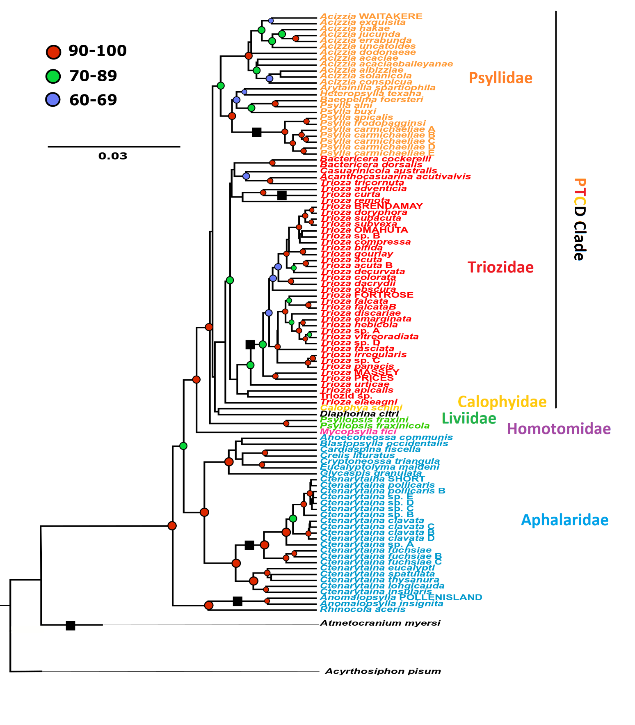

**Figure 1:** **Species tree of the New Zealand Psylloidea included in this study.** The tree was inferred from 668 DNA sequences of partial COI, EF-1α and 18S genes using BEAST v.2.5.0. The families Psyllidae (orange), Triozidae (red) and Calophyidae (*Calophya schini;* yellow), together with *Diaphorina citri* (black) form the PTCD clade, as reported in (Percy *et al.* 2018). *Acyrthosiphon pisum* (Hemiptera) was used as an out group. New Zealand endemic species are indicated with black squares on branches showing ancestral arrivals of native species. Posterior probability values at the nodes are reported in red when ranging between 0.9 and 1; in green when between 0.7 and 0.89; and in blue when between 0.6 and 0.69. Posterior probability values lower than 0.6 are not reported.

* 1. ***Microbiome composition***

**Bacterial diversity**

Following sequence quality filtering and curation a total of 9,258,360 sequences were retailed from 246 specimens of 74 taxa (mean = 37636; se = 2503; range = 1177-231159) consisting of 621 unique amplicon sequence variants (ASVs) (mean =42.3; se=1.52; range = 5-151). The ASV’s recovered represented 21 distinct bacterial phyla and 126 unique genera. The most prevalent bacterial phylum was Proteobacteria (in all 246 specimens), followed by Bacteroidota (237 specimens), Actinobacteriota (192 specimens) and Firmicutes (165 specimens). This was similarly reflected in their abundance, with Proteobacteria being the most abundant bacterial phylum, accounting for 8,486,237 sequence reads (91% of dataset), followed by Bacteroidota (2.6%), Firmicutes (1.07%), and Actinobacteriota (0.4%). Within the phylum Proteobacteria, the orders *Burkholderiales*, *Rhizobiales*, Gammaproteobacteria *Incertae Sedis* (an order within the Silva 138 taxonomy containing the primary symbiont *Candidatus* Carsonella) and *Enterobacterales* were the most prevalent, while *Enterobacterales*, *Rickettsiales* and *Pseudomonadales* were the most abundant (Fig 2). At the genus level, the most abundant taxon was *Wolbachia*, which occurred in a high titre across many samples and accounted for 19% of the total sequences, followed by *Sodalis* (8.2%) and *Arsenophonus* (5.4%). In contrast, the most prevalent genera were *Aquabacterium* (233 specimens), *Candidatus* Carsonella (217 specimens), *Sulfuriatalea* (208 specimens) and *Sediminibacterium* (199 specimens).

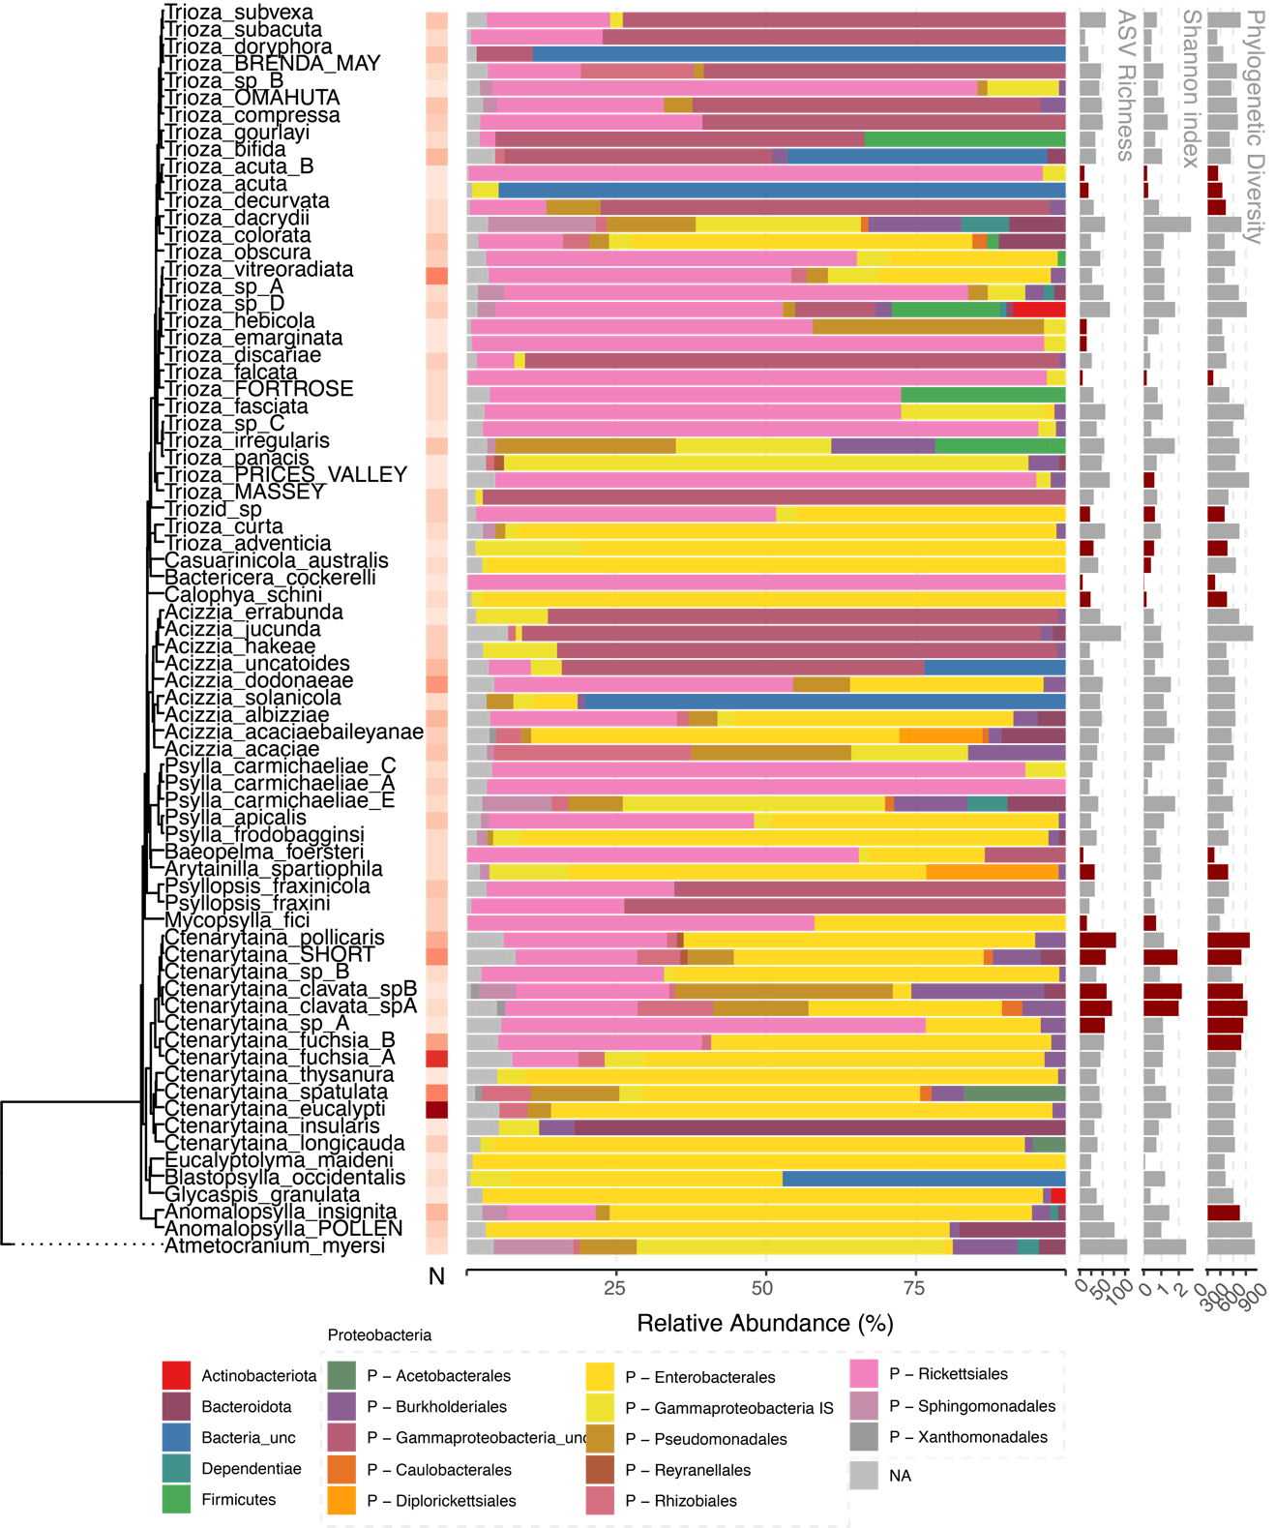

**Figure 2:** Overview of microbiome results by species

Alpha diversity

ANOVA found statistically significant differences between psyllid species for observed ASV richness (F(73, 172) = 2.47, p < .001), Shannon’s index (F(73, 172) = 3.02, p < .001), and phylogenetic diversity (F(73, 172) = 2.72, p < .001), all with large effects (partial omega squared = 0.37, 0.37 and 0.34 respectively). The differences in ASV richness was found to be significantly associated with psyllid phylogeny using both autocorrelation (I=0.24, p<0.001), and Brownian motion statistics (K = 0.34, λ = 0.84 p<0.001). Similar result was found for Shannon’s index (I= 0.018, K=0.21, λ = 0.78, p<0.001). On the other hand, the phylogenetic diversity of microbes within each psyllid sample was not found to be significantly autocorrelated with phylogeny with most measures (I= 0.009, p=0.058), K=0.08, p=0.11, λ = 0.648, p<0.05). Significant local autocorrelation between richness and Shannon’s index, and the psyllid phylogeny was concentrated around the *Ctenarytaina clavata* clade, and the *Trioza* *acuta* clade (Figure 2). To ensure robustness to different sample sizes, the data was rarefied to the smallest sample and these tests repeated, with the same conclusions (Supplementary Figures 1a and 1b).

Beta diversity & Phylosymbiosis

For microbial beta diversity, visual inspections of PCA plots on the microbiome Aitchison distances (Supplementary Figure 2A, 2B and 2C) indicated that a mixture of both x? and dispersion effects are likely to play a role in the differences between the microbiomes (Figure 2). This was supported by permutation tests on the distance matrices, with the taxonomic structure of their psyllid host explained significant variance (Adonis, R2 = 0.47, p<0.001), as well as s differences in dispersion (PERMDISP). The taxonomic structure of hostplant of each psyllid specimen also explained a significant amount of variance (Adonis, R2 = 0.35, p<0.001) and dispersion (PERMDISP), however less than the psyllid taxonomic structure. For psyllid collected off the same individual hostplants the hostplant explained a small amount of variance (R2= 0.009, p<0.05), while the psyllid identity continued to explain the largest portion of the variance (R2 = 0.52, P< 0.001). To determine if the significant effect of psyllid and hostplant species on microbiome composition was due to shared evolutionary history, matrix correlation tests were conducted between the microbiome beta diversities and the psyllid phylogenetic distance, hostplant phylogenetic distance and spatial distance. Mantel tests found significant positive correlation between microbiome and psyllid phylogenetic distance (r=0.23, p<0.001) but no significant correlation between microbiome and hostplant phylogenetic distance (r=0.04, p=0.19), or microbiome and spatial distance (r=0.02, p=0.65) (Figure 3A). Similarly, partial mantel tests found significant positive correlation between microbiome and psyllid phylogenetic distance when hostplant distance and spatial distance were controlled for (r=0.22, p<0.001), and found no significant correlation between microbiome and hostplant phylogenetic distance, when psyllid phylogenetic distance and spatial distance were controlled for (r=-0.02, p=0.55) or spatial distance when psyllid and hostplant phylogenetic distances were controlled for (r=0.024, p=0.65) (Figure 3B). To ensure patterns of phylosymbiosis were not being driven only by the known symbionts, correlation analyses were repeated without the class Gammmaproteobacteria, that includes both the primary and secondary symbionts. With this subset data a significant albeit reduced correlation was found between the microbiome and psyllid phylogenetic distance for both Mantel (r=0.2, p<0.05) and Partial Mantel tests (r=0.2, p<0.05), while hostplant and spatial distance remained insignificant (supplementary n).

**Figure 3:** Phylosymbiosis – Results of Mantel tests (**A**), partial Mantel tests (**B**), and beta diversity through time analysis (**C**).

In order to investigate the phylogenetic scale of the phylosymbiosis patterns, beta diversity through time analysis was used to slice the microbiome phylogeny at 10Mya timepoints and recalculate partial Mantel correlations. Microbiome beta diversity and psyllid phylogenetic distance remained significantly correlated at all time-slices with the correlation peaking at approximately 100 Mya, before falling to a plateau at approximately 500Mya (Figure 3C). In contrast, the correlation between microbiome and hostplant phylogenetic distance, as well as microbiome and spatial distance was not significant at any point in the time slices.

Cophylogeny

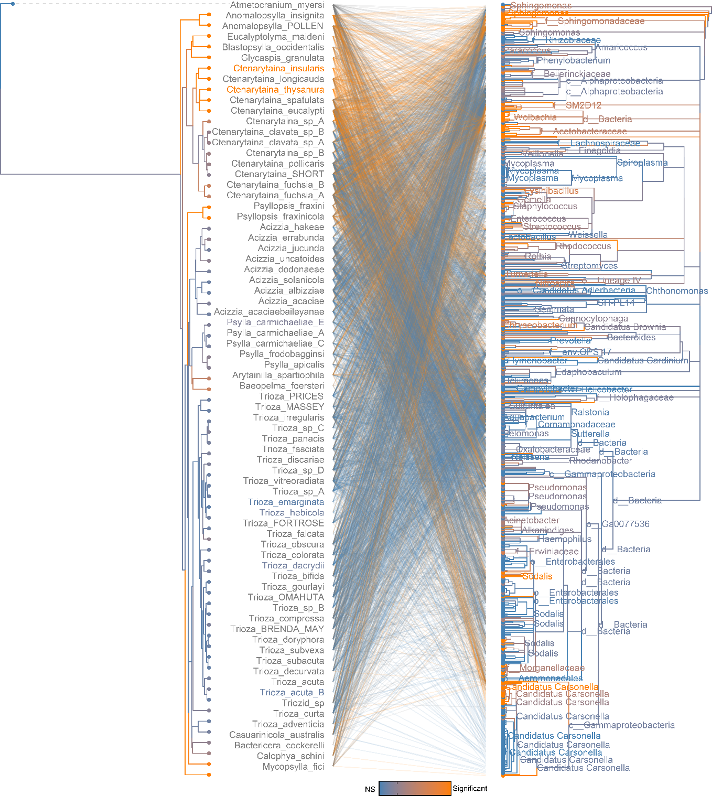

**Figure 4**: Phylogenetic congruence between psyllid species and microbiome. Links and taxa coloured according to their contribution to PACo global fit.

The co-phylogenetic signal between the psyllid phylogeny and the microbiome phylogeny was compared using ParaFit and PACo algorithms. While the global fits for both the ParaFit statistic and PACo goodness-of-fit were low (ParaFitGlobal=2695,920) and ( m2xy=0.9931) respectively, the observed interaction network between the psyllid and microbial taxa was still found to be significantly more congruent than any of the 100,000 permuted instances using both algorithms (p<0.001). Low global fits are common with complex interaction networks such as when comparing a whole microbiome (ref), and when looking at contributions of individual interactions, 1498 interactions were found to be significant with ParaFit, and 1180 interactions with PACo (Figure 4). On the microbial side, unsurprisingly many links associated with the primary symbiont *Candidatus* Carsonella rudii were found to show congruence with a hypothesis of cophylogeny. However, in addition to the primary symbiont, other bacterial genera showed a higher number of significant links from both ParaFit and PACo, including *Reyreanella*, *Novosphingobium*, *Sphingomonus* and *Wolbachia* (Figure 4; Figure 5). While many of these taxa were not as prevalent across psyllid specimens as *Carsonella*, they could represent secondary symbionts. When the PACo algorithm was fit between the psyllid species and the *Candidatus* Carsonella ASVs alone, the goodness-of-fit between the two phylogenies was much higher than seen in the entire assemblage for both Parafit (ParaFitGlobal=2032.17, p<0.001) and PACo (m2xy=0.15, p<0.001) (Supplementary Figure 3). In addition to the significant signal between psyllids and their associated microbiome, cophylogenetic significant congruences were also seen between the psyllids and their hostplant species for both ParaFit (ParaFitGlobal=1451.17, p<0.001) and PACo (m2xy=0.53, p<0.001) (Supplementary Figure 4).

When these algorithms were again fit to just psyllids of the *Trioza* genus and their associated microbiome (Supplementary Figure 5), ParaFit still inferred a significant but slight congruence between the two phylogenies and interaction network (ParaFitGlobal=109,615.2, p<0.001) (Figure 6), however the PACo goodness-of-fit statistic was not significant (m2xy=0.9911, p>0.05) compared to the 100,000 randomisations. a number of significant individual interactions stood out such as the microbial genera *Reynarella*, *Wolbachia*, *Novosphingobium* and *Candidatus* Carsonella. Interestingly, the genus *Mycoplasma* appeared to have a strong significance (Figure 6). While on the *Trioza* tree, the taxa with the highest number of significant links were *Trioza* “Prices Valley”, *T.* “Massey” and *Trioza curta* and *T. adventicia*. When ParaFit and PACo were refit to the *Trioza* and *Candidatus* Carsonella ASV’s the congruence found with both algorithms was increased compared to that seen between with the larger psyllid dataset, but to a higher degree with ParaFit (ParaFitGlobal=46.39, p<0.001) than PACo (m2xy=0.13, p<0.001) (Supplementary Figure 6). Similarly, the congruence between the *Trioza* and their hostplants was increased compared to the larger dataset with both algorithms (ParaFitGlobal=109.83, m2xy=0.48, p<0.001) (Supplementary Figure 7).

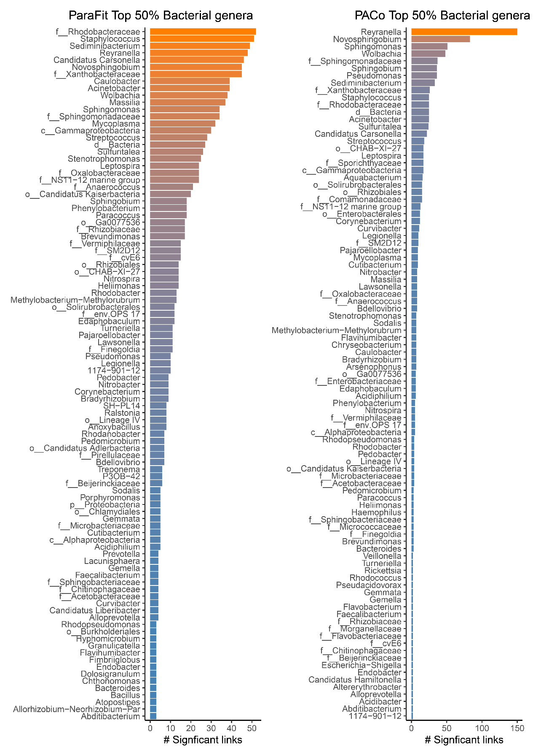

**Figure 5:** Number of significant links from each microbial genus contributing to phylogenetic congruence between psyllid species and their microbiome for both ParaFit and PACo

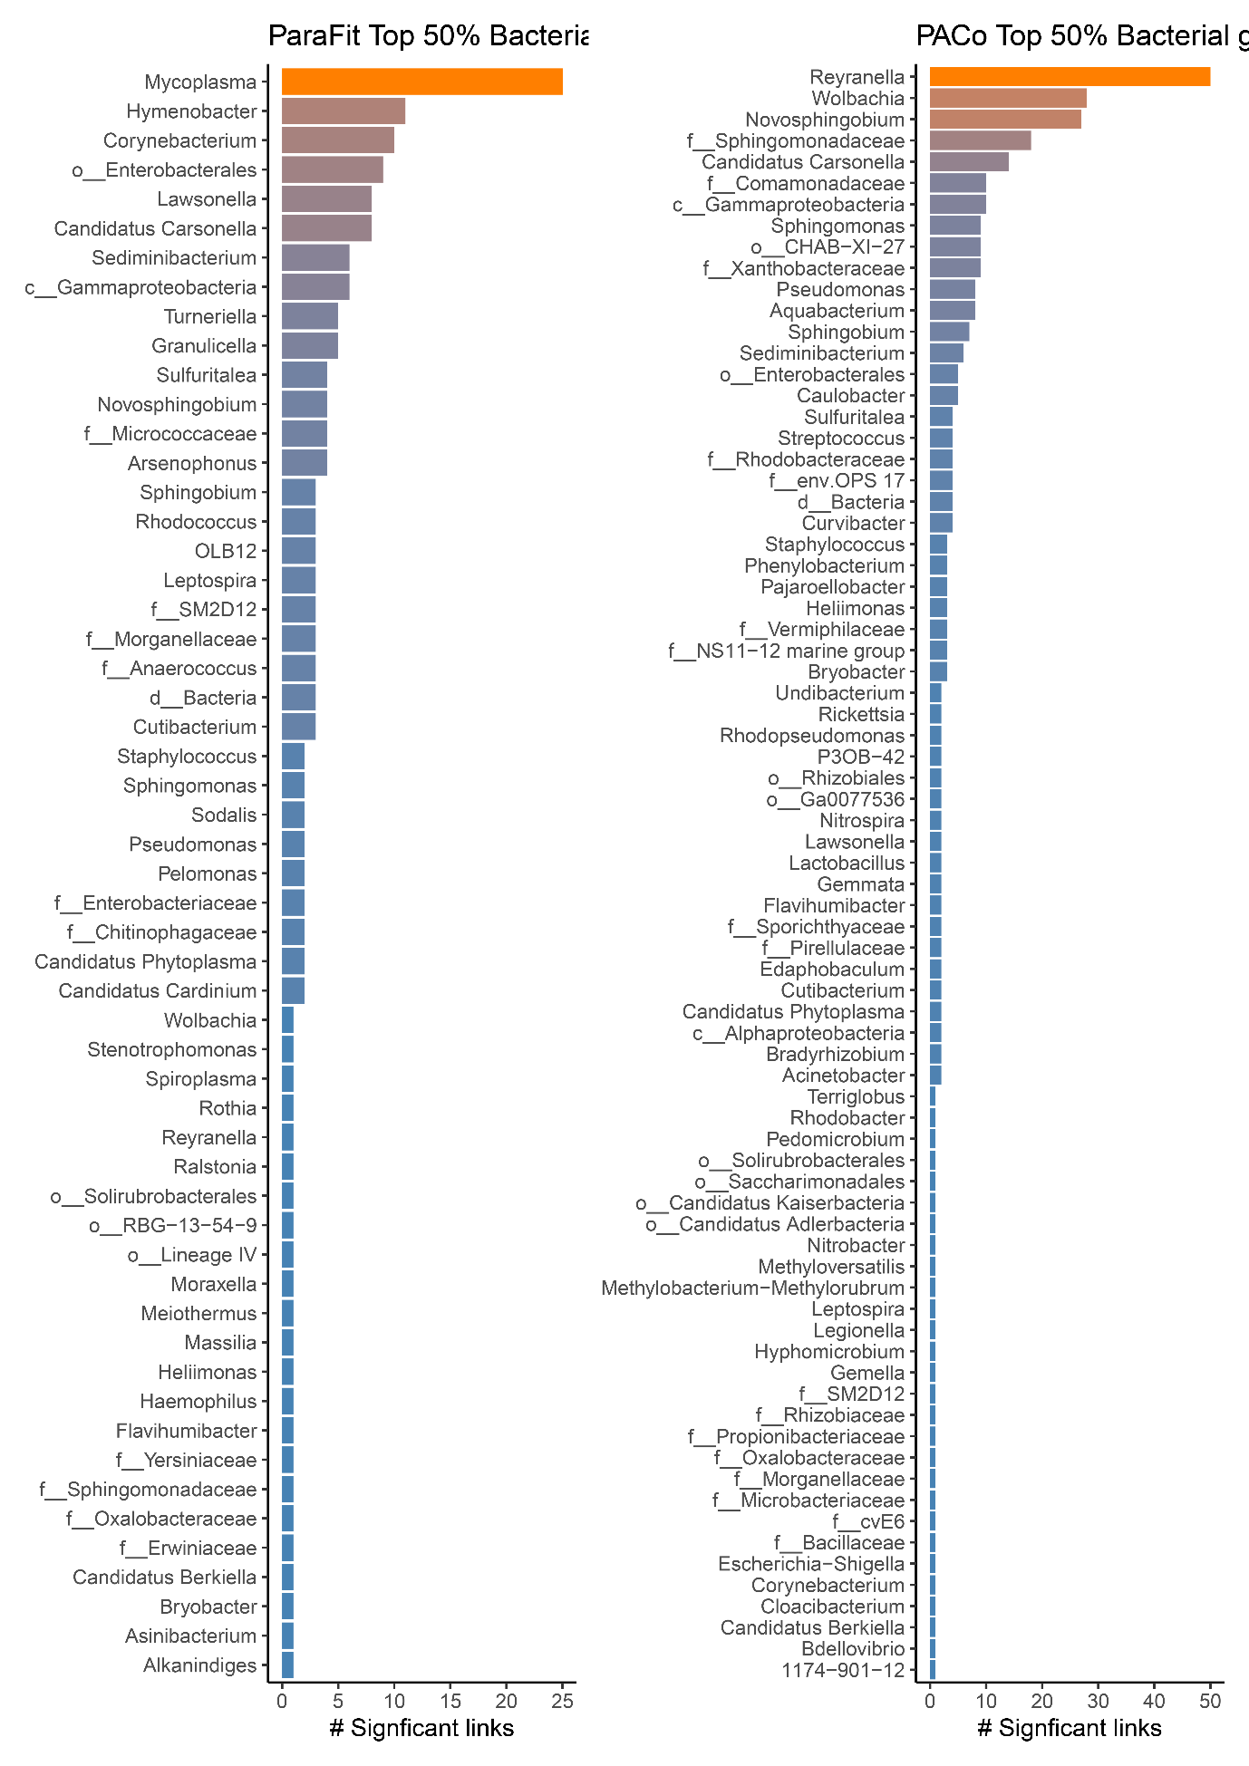

**Figure 6:** Number of significant links from each microbial genus contributing to phylogenetic congruence between Trioza species and their microbiome for both ParaFit and PACo

1. **Discussion**

I’m currently a big fan of starting the Discussion with a three sentence summary of the main findings. It’s quite useful to get the writer and reader into the proper thinking space.

* 1. ***The phylogenetic structure of the New Zealand psyllids confirms monophylies and ancestral arrivals of today’s New Zealand endemic psyllids.***

The general shape of the species tree, especially at a taxonomic level, matches the most recent phylogenetic works on the worldwide Psylloidea at a family level (e.g., Percy *et al.* 2018; Cho *et al.* 2019). The families Psyllidae, Triozidae and Calophyidae, together with the species *Diaphorina citri,* form the PTCD clade (Percy *et al.* 2018), at the top of the tree, and were separated from the family Liviidae, represented in New Zealand by the two non-native species of the genus *Psyllopsis*, with maximum posterior probability support (Figure 1). Similarly, the family Homotomidae is represented by a single adventive species, *Mycopsylla fici,* branching with maximum posterior probability (Figure 1). At the base of the tree, the family Aphalaridae appears to be paraphyletic, with the subfamily Rhinocolinae branching earlier than the Spondyliaspidinae, in accordance with the most recent works (Cho *et al.* 2019). Separated from all the other families, a single branch that included the species *Atmetocranium myersi* showed no affinity to any other group. Therefore, the species tree obtained here appears robust and well supported at both deeper and shallower nodes, despite the use of a relatively small number of markers, supporting the previously defined taxonomic relationships between species, genera and families, as defined by their morphological characteristics (Burckhardt and Ouvrard 2012). Hence, this phylogenetic structure can be used further for comparisons and to determine evolutionary history for a number of New Zealand psyllid groups.

This study shows that all New Zealand *Trioza* species (except *T. curta*) form a monophyletic grouping derived from a single arrival to New Zealand. The New Zealand *Trioza* were not clearly related to the represented Australian triozids. However, the Australian triozids are also distant from one another, suggesting that they may not be a natural monophyletic group. This could be the result of multiple dispersals to Australia or it could suggest they are the remnants of a larger Australian group that has lost members over time.In order to understand the origin of the New Zealand *Trioza* a more complete sampling of triozids from the Asia-Pacific is required. In particular, it would be advantageous to study *T. oleariae* Froggatt 1903, from Tasmania which is hosted by *Olearia* (Asteraceae) (Hollis 2004), as are many of the New Zealand *Trioza*. *T. curta* appears to be from a second distinct ancestral arrival, and appears to be of Australian origin, considering its relative genetic similarity to *T. adventicia.*

The seven *Psylla* species in New Zealand formed a monophyletic grouping. *Psylla* species are absent in Australia (Hollis 2004) while European *Psylla* included in this study appear more closely related to other genera in the Psyllidae. Therefore, the New Zealand clade appears to belong to an entirely different genus. Morphological characters such as 8-segmented antennae and marginal setae on the caudal plate place New Zealand *Psylla* within the Psyllinae but outside *Psylla* as hypothesised elsewhere (Martoni *et al.* 2016). Nevertheless, the taxa included here are insufficient to determine the closest relatives of the New Zealand *Psylla*; inclusion of *Psylla compta* Crawford, 1919 from Fiji - as the closest location to New Zealand - would be a first step (Ouvrard 2020).

Another monophyletic group is composed by the New Zealand species of the genus *Ctenarytaina.* There are five *Ctenarytaina* species in Australia (Ouvrard 2020) and a number of *Ctenarytaina* species from there is adventive to New Zealand (Martoni *et al.* 2016). Hence, an Australian origin of the New Zealand *Ctenarytaina* species could be hypothesised. Nonetheless, a number of *Ctenarytaina* species are also distributed across the Pacific islands, e.g. *C. distincta* (Tuthill, 1943) from Fiji, *C. lulla* Tuthill, 1942 and *C. remota* Tuthill, 1956 from French Polynesia (Ouvrard 2019; Tuthill, 1942, 1943, 1956), which highlights the importance of wider geographic collections in the future (Martoni and Armstrong 2019a). Possible alternative sources to Australia is also consistent with the fact that there are no *Psylla* in Australia (Hollis 2004; Ouvrard 2019). But their worldwide presence includes *P. compta* Crawford, 1919 in Fiji as the closest location to New Zealand (Ouvrard 2019).

The phylogenetic position of *Anomalopsylla* is consistent with recent taxonomic classifications placing this genus in the subfamily Rhinocolinae, distinctly separated from the other aphalarid genera included here (subfamily Spondyliaspidinae; Burckhardt and Ouvrard 2012). While the subfamily Rhinocolinae includes 13 genera distributed worldwide (Burckhardt and Lauterer, 1989), *Anomalopsylla* is the only genus present in the Asia-Pacific area and the only one hosted by Asteraceae. The addition to the analysis of the European species *Rhinocola aceris* highlighted how this species is relatively phylogenetically close to *Anomalopsylla.*

Finally, *Atmetocranium myersi,* the only representative of this genus, showed no phylogenetic affinity with any other psyllid species or family.In a recent morphological classification of the Psylloidea, *Atmetocranium* was tentatively placed within the Calophyidae, because of its distinctive metatibia (Burckhardt and Ouvrard 2012). The Calophyidae includes at least 118 species (Ouvrard 2019), but none are native to New Zealand. *Atmetocranium* was earlier placed with the Aphalaridae, based on wing morphology (Klimaszewski 1964). Based on the results obtained here, it would appear that it does not belong to any of the Aphalaridae subfamilies included here. Samples from the other three subfamilies (Aphalarinae, Pachypsyllinae and Togepsyllinae) will need to be analysed before a linkage between *Atmetocranium* and Aphalaridae can be dismissed. Furthermore, the superfamily Psylloidea includes another two families not present in New Zealand, Carsidaridae and Phacopteronidae (Burckhardt and Ouvrard 2012), that appear to be genetically close to the family Aphalaridae (Percy *et al.* 2018). However, *A. myersi* has also been noted as having a “highly autapomorphic morphology which makes it difficult to relate to other psylloid groups” (Mifsud and Burckhardt 2002). This detail appears to be in agreement with the results obtained here, showing a clear separation between *Atmetocranium* and all the other psyllid families presented in this study. This, together with its peculiar morphology (Mifsud and Burckhardt 2002), suggest that *Atmetocranium* could belong to an entirely new psyllid family.

* 1. ***The microbial diversity harboured by the New Zealand psyllids***

*Microbiome diversity*

The microbial dataset generated and analysed here included 267 psyllids, belonging to 75 species, 18 genera and six families. This is a significant increase in the number of species studied when compared to previous such studies that either focused on a smaller taxonomic range of insects, such as the Australian genus *Cardiaspina* (Hall *et al.* 2016) or used different techniques that generated smaller numbers of sequences (Thao *et al.* 2000b, Spaulding and von Dohlen 2001). This wider focus aimed to enable a better understanding of the microbiome composition of psyllids across different families and genera.

Of all the bacteria recorded here, the phylum Proteobacteria was that only one present in all samples (most prevalent) and also the one accounting for the highest number of reads (most abundant, with 91% of the total). This is consistent with the expectation, based on the fact both the p-symbiont and the S-symbionts belong to this group. Indeed, within Proteobacteria, the most prevalent orders were Enterobacterales, Burkholderiales, Rhizobiales and an undescribed order listed as ‘Gammaproteobacteria Incertae Sedis’ (an order within the Silva 138 taxonomy containing the primary symbiont *Candidatus* Carsonella). While, Enterobacterales, Rickettsiales and Pseudomonadales were also the most abundant across the species analysed. At the genus level, the most abundant taxon was *Wolbachia*, often occurring at a high titre across many samples (19% of the total sequences). As previously reported in other psyllids (Hall *et al.* 2016). Previously recorded psyllid S-symbionts (Thao *et al.* 2000b; Hall *et al.* 2016) that were found here are *Sodalis* (8.2% of total reads) and *Arsenophonus* (5.4% of total reads). The role of such generaas S-symbionts has been reported for other insects such as Glossinidae flies (Diptera) (Aksoy *et al.* 1997), lygaeid stinkbugs (Matsuura *et al.* 2012) and weevils (Heddi *et al.* 1998). Ultimately, the number of reads and the distribution of the bacterial taxa across the psyllid groups suggest that some Enterobacteriaceae S-symbionts of psyllids have a strong history of coevolution with the members of this insect superfamily.

In contrast, the most prevalent genera were *Aquabacterium* (233 specimens), *Candidatus* Carsonella (217 specimens), *Sulfuriatalea* (208 specimens) and *Sediminibacterium* (199 specimens). Given the status of *Candidatus* Carsonella rudii as an obligate primary symbiont in psyllids (Thao *et al.* 2000a, Thao *et al.* 2001, Hall *et al.* 2016), this was expected to be found in all psyllids. This might be due to its generally low relative abundance within all samples and high deviation (mean= 5.8%, sd=14.1%). This absence in certain specimens could be due to stochastic processes and insufficient sequencing depth.

*The Psyllids-bacteria relationship: a new case of phylosymbiosis.*

After confirming that the microbial composition of psyllids was not randomly distributed (alpha and beta diversity, using ANOVA) we could associate this variation with psyllid phylogeny. While of a lesser degree, the host plant taxonomy accounted for a significant variation as well as the geographical distribution (using both Adonis and PERMDISP). This is in accordance with the fact that psyllids are extremely species-specific in their host plant associations.

Both Mantel and partial mantel tests found a significant correlation between microbiome and psyllid phylogenetic distance, and a lesser signal between microbiome and host plant phylogenetic. This signal may be driven by the strong co-evolutionary relationship between psyllids and their primary and secondary symbionts, known to be vertically transmitted (Hall *et al.* 2016).

When all Gammaproteobacteria, including *Candidatus* Carsonella and secondary symbionts belonging to the Enterobacteriales (e.g., *Sodalis*) were removed from the analysis,there remained a signal between the microbiome diversity and the psyllid phylogenetic history. This confirmed such relationship is not driven solely by primary and secondary symbionts. Further analyses allowed us to highlight groups of bacteria having a possible symbiotic role in psyllids. Other bacterial genera showed a higher number of significant links from ParaFit and PACo included *Reyranella*, *Novosphingobium*, *Sphingomonas* and *Wolbachia*. While many of these taxa were not as prevalent across psyllid specimens as *Carsonella*, they are hypothesised here to be secondary symbionts of psyllids.

Previous studies focusing both on the P-symbiont (Thao *et al.* 2000a, Spaulding and von Dohlen 2001, Thao *et al.* 2001, Hall *et al.* 2016) and on the S-symbionts (Thao *et al.* 2000b, Hall *et al.* 2016, Morrow *et al.* 2017), showed different degrees of association between psyllids and these two groups of bacteria. This includes recent studies confirming degrees of vertical transmission for a few S-symbionts in addition to *Carsonella* (Hall *et al.* 2016). Based on our results, we hypothesise that vertical tranmission is the most probable mean of transmission of many more bacteria than previously reported.

This suggest that the association between the New Zealand psyllids and their microbiome can be defined as a “Phylosymbiosis”. Phylosymbiosis is any significant association between the phylogenetic structure of a group of organisms and their associated microbial community (Brucker and Bordenstein 2012; Brooks *et al.* 2016; Lim and Bordenstein 2019). The association between the New Zealand psyllids phylogenetic structure and their microbiome composition fits with the notion that evolutionary changes in the insect host are associated with ecological changes in its microbiome (Sanders *et al.* 2014; Brooks *et al.* 2016). For example, this could explain why psyllid lineages that colonised different ecological niches present variations in their microbiome composition. Furthermore, a phylosymbiotic pattern within the microbiome of closely related species can highlight the presence of specific groups of bacteria providing their hosts with adaptive traits (Lim and Bordenstein 2019).

Therefore, we can hypothesise that an archaic psyllid lineage – such as *Trioza* - that might have been forced to colonise a new host plant (for example, due to environmental factors such as geographical isolation) could have been aided by the association with bacteria providing the metabolic traits to feed on it. Such bacteria could have been newly acquired or had previously provided other evolutionary advantages. An example of such an instance is the case of the facultative symbiont *Regiella insecticola* that might have allowed the pea aphids to colonise clover (Oliver *et al.* 2014; Flórez *et al.* 2015), while it had been previously selected because it could confer resistance against the aphid fungal pathogen *Pandora* often present on that plant(Hrček *et al.* 2016; Sochard *et al.* 2019; Frago *et al.* 2020).

* 1. ***Psyllid-bacteria-hostplants: the case of the New Zealand Trioza***

In order to test the hypothesis presented above, we focused on the most numerous genera present in New Zealand: *Ctenarytaina, Psylla* and *Trioza.* Confirming a trend widely accepted elsewhere for psyllids (e.g., Ouvrard *et al.* 2015), New Zealand *Ctenarytaina* and *Psylla* are associated with only one or a few host plant families (Burckhardt *et al.* 2014). On the other hand, worldwide, *Trioza* shows an unusually large range of plant genera associations, with a recent study listing 346 *Trioza* psyllid species on 154 plant genera in 59 plant families (Ouvrard *et al.* 2015). However, it was unclear so far if *Trioza* psyllids are more prone to host switching, or if the potentially polyphyletic nature of this genus may distort the breadth of host plant associated with this genus (Ouvrard *et al.* 2015). The New Zealand species were known to be consistent with the worldwide genus in that they do occupy many different host plant families (Martoni *et al.* 2016), but the lack of a phylogenetic structure could not clarify if the genus was monophyletic.

The results of this phylogenetic analysis suggest the monophyly of the New Zealand *Trioza*, hence demonstrating that *Trioza* species have indeed acquired a large number of new hosts since arriving in New Zealand, and that this is not a case of polyphyly. Therefore, pairing the phylogeny of the New Zealand *Trioza* analysed in this study with their host plants shows for the first time how the radiation of the psyllids developed on multiple plant genera and families after the arrival of the first ancestral *Trioza* psyllid to New Zealand.

For example, the Asteraceae, hosting 14 *Trioza* species, appears to be the result of multiple colonization events from these insects. With a cluster of 12 closely related psyllid species positioned apically in the tree (Supplementary Figure 7) suggesting a more recent colonization event as compared to the association between *T.* “Massey” or *T.* “Fortrose”, distant from the other Asteraceae feeding psyllids. Similarly, a single psyllid species in the cluster, *T. decurvata*, is found on *Dracophyllum* (Ericaceae) which, although positioned within the same major plant clade as the Asteraceae, is remote from it. Prior to this study, Asteraceae had been thought to be the ancestral host of New Zealand *Trioza* based on morphology and host associations (Martoni *et al.* 2016). However, the host association with Asteraceae was not clear-cut; while one of the earliest diverging species, *T.* “Massey” has an Asteraceae host, most of the remaining Asteraceae inhabiting psyllids appeared to have derived from a more recent host adoption/speciation event. Another example is the association between the psyllids *T. colorata* and *T. dacrydii* with the Podocarpaceae (*Halocarpus bidwillii*), a conifer lineage. These two psyllid species are branching within the broader clade of *Trioza*, suggesting a shift from an angiosperm host within New Zealand.

When comparing the phylogenetic congruence between the *Trioza* species and their microbiome (Supplementary Figure 5), the taxa contributing more significantly to the PACo global fit are the the two branching earlier in time: *Trioza* ‘Price’s Valley and *T.* ‘Massey’. This might suggest how these more archaic triozids carry a microbiome diversity strictly linked.

When examining the microbial composition of the *Trioza* species, a few bacterial genera were highlighted for having a strong presence across species and, therefore, a potential role in their ecology. Amongst these genera were *Mycoplasma, Hymenobacter, Corynebacterium, Reyranella, Wolbachia* and *Novosphingoboium.* Considering the peculiar multi-host plant associations recorded for the genus *Trioza* in New Zealand, these bacteria might play an important role in the host plant association of these psyllid species, possibly allowing and/or facilitating host switches.

1. ***Conclusion.***

Based on the results obtained here, we suggest that the psyllid-microbiome associations are strongly influenced by the insects’ phylogenetic relationships as opposed to the host plant association. This is confirmed by the present phylosymbiotic signal recorded between the New Zealand psyllids and their microbiomes, highlighting the major role of vertically transmitted bacteria, playing an important part in shaping the psyllids microbiome composition. Furthermore, while vertical transmission was previously hypothesised only for P-symbiont and a few S-symbionts, we reported here that a much bigger percentage of the microbiome of psyllids has been co-evolving with their hosts.

**Acknowledgements.**

The authors would like to acknowledge the support of the Australian Plant Biosecurity Research Centre during FM’s PhDv(PBCRC). Thanks to Susan Halbert (FSCA) for helping FM collecting psyllids in Florida, USA. Thanks to Marona Rovira Capdevila, Samuel Brown and Aimee Claire McKinnon for helpful suggestions. Part of the data published in this article was reported in FM’s PhD thesis (Martoni 2017).

**References.**

* Abouheif, E. 1999. A method for testing the assumption of phylogenetic independence in comparative data. *Evolutionary Ecology Research*, 1: 895–909.
* Ahmed, M.Z., Breinholt, J.W. & Kawahara, A.Y. 2016. Evidence for common horizontal transmission of Wolbachia among butterflies and moths. *Bmc Evolutionary Biology*, 16: 118. https://doi.org/10.1186/s12862-016-0660-x.
* Aitchison, J., Barceló-Vidal, C., Martín-Fernández, J.A. & Pawlowsky-Glahn, V. 2000. Logratio analysis and compositional distance. *Mathematical Geology*, 32(3): 271-275.
* Aksoy, S., Chen, X. & Hypsa, V. 1997. Phylogeny and potential transmission routes of midgut-associated endosymbionts of tsetse (Diptera: Glossinidae). *Insect Molecular Biology*, 6: 183-190.
* Anselin, L. 1995. Local indicators of spatial association—LISA. *Geographical analysis*, 27(2): 93-115.
* Balbuena, J. A., Míguez-Lozano, R., & Blasco-Costa, I. 2013. PACo: a novel procrustes application to cophylogenetic analysis. *PLOS ONE*, 8(4).
* Baumann, P. 2005. Biology of bacteriocyte-associated endosymbionts of plant sap-sucking insects. *Annual Review of Microbiology*, 59: 155-189.
* Bekker-Migdisova, E.E. 1973. *Systematics of the Psyllomorpha and the position of the group within the order Homoptera*. In: Narchuk, E.P. (Ed.), Doklady na Dvadsat Chetvertom Ezheghodnom Chtenii Pamyati N. Voprosy paleontologii nasekomykh, Leningrad, pp. 90-117.
* Bennett, A.E. 2013. Can plant–microbe–insect interactions enhance or inhibit the spread of invasive species? *Functional Ecology*, 27: 661–671.
* Bivand, R.S., Pebesma, E.J. & Gomez-Rubio, V. 2013. *Applied spatial data analysis with R*, Second edition. Springer, NY. 376 pp.
* Blomberg S.P., Garland T.Jr. & Ives A.R. 2003. Testing for phylogenetic signal in comparative data: behavioral traits are more labile. *Evolution*, 57: 717–745.
* Bouckaert, R., Heled, J., Kühnert, D., Vaughan, T., Wu, C-H., Xie, D., Suchard, M.A., Rambaut, A. & Drummond, A.J. 2014. BEAST 2: A Software Platform for Bayesian Evolutionary Analysis. *PLOS Computational Biology,* 10(4), e1003537. doi:10.1371/journal.pcbi.1003537.
* Bouckaert, R., Vaughan, T.G., Barido-Sottani, J., Ducheene, S., Fourment, M., Gavryushkina, A., Heled, J., Jones, G., Kuhnert, D., De Maio, N., Matschiner, M., Mendes, F.K., Muller, N.F., Ogilvie, H., du Plessis, L., Popinga, A., Rambaut, A., Rasmussen, D., Siveroni, I., Suchard, M.A. & Wu, C.-H. 2018. BEAST 2.5: An Advanced Software Platform for Bayesian Evolutionary Analysis. *bioRxiv preprint*, first posted online Nov. 19, 2018; doi: <http://dx.doi.org/10.1101/474296>.
* Bright, M. & Bulgheresi, S. 2010. A complex journey: transmission of microbial symbionts. *Nature Reviews Microbiology,* 8, 218–230.
* Brooks, A.W., Kohl, K.D., Brucker, R.M., van Opstal, E.J. & Bordenstein, S.R. 2016. Phylosymbiosis: Relationships and Functional Effects of Microbial Communities across Host Evolutionary History. *PLOS Biology*, 15(1): e1002587. <https://doi.org/10.1371/journal.pbio.1002587>
* Brown, R.G. & Hodkinson, I.D. 1988. Taxonomy and Ecology of the Jumping Plant-Lice of Panama (Homoptera: Psylloidea). *Behaviour*, 107: 131-131.
* Brucker, R.M. & Bordenstein, S.R. 2012. Speciation by symbiosis. *Trends in Ecology and Evolution*, 27(8): 443-451.
* Buckley, T.R., Krosch, M. & Leschen, R.A.B. 2015. Evolution of New Zealand insects: summary and prospectus for future research. *Austral Entomology*, 54: 1-27.
* Burckhardt, D.& Lauterer, P. 1989. Systematics and biology of the Rhinocolinae (Homoptera: Psylloidea). *Journal of Natural History*, 23(3): 643-712, DOI: 10.1080/00222938900770371
* Burckhardt, D. & Ouvrard, D. 2012. A revised classification of the jumping plant-lice (Hemiptera: Psylloidea). *Zootaxa,* 3509: 1–34
* Burckhardt, D., Ouvrard, D., Queiroz, D. & Percy, D. 2014. Psyllid Host-Plants (Hemiptera: Psylloidea): Resolving a Semantic Problem. *Florida Entomologist*, 97: 242-246.
* Bushnell, B. 2017. BBMap website, available at: sourceforge.net/projects/bbmap/
* Callahan, B.J., Sankaran, K., Fukuyama, J.A., McMurdie, P.J. & Holmes, S.P. 2018. Bioconductor Workflow for Microbiome Data Analysis: from raw reads to community analyses [version 2; referees: 3 approved]
* Chamberlain, S. 2019. brranching: Fetch 'Phylogenies' from Many Sources. R package version 0.5.0. <https://CRAN.R-project.org/package=brranching>.
* Cho, G., Malenovsky´, I. & Lee, S. 2019. Higher-level molecular phylogeny of jumping plant lice (Hemiptera: Sternorrhyncha: Psylloidea). *Systematic Entomology*, https://doi.org/10.1111/syen.12345 PMID: 30988552.
* Chu, C.C., Spencer, J.L., Curzi, M.J., Zavala, J.A. & Seufferheld, M.J. 2013. Gut bacteria facilitate adaptation to crop rotation in the western corn rootworm. *Proceedings of the National Academy of Sciences of the United States of America*, 110: 11917-11922.
* Colman, D.R., Toolson, E.C. & Takacs-Vesbach, C. 2012. Do diet and taxonomy influence insect gut bacterial communities? *Molecular Ecology*, 10/01; 2019/04;21(20):5124-5137.
* Dale, C. & Moran, N.A. 2006. Molecular interactions between bacterial symbionts and their hosts. *Cell*, 126: 453-465.
* Dale, P.J. 1985. *A review of the Psylloidea (Insecta: Hemiptera) of the New Zealand subregion*. Unpublished PhD Thesis. University of Auckland, Auckland.
* de Vienne, D.M., Aguileta, G. & Ollier, S. 2011. Euclidean nature of phylogenetic distance matrices. *Systematic biology*, 60(6), 826-832.
* Douglas, A.E. 2016. How multi- partner endosymbioses function. *Nature Reviews Microbiology*, 14: 731-743.
* Drummond, A.J. & Bouckaert, R.R. 2015. *Bayesian evolutionary analysis with BEAST*. Cambridge University Press. 249 pp.
* Drummond, A.J., Suchard, M.A., Xie, D. & Rambaut, A. 2012. Bayesian Phylogenetics with BEAUti and the BEAST 1.7. *Molecular Biology and Evolution*, 29: 1969-1973.
* Eastman, J.M., Harmon, L.J. & Tank, D.C. 2013. Congruification: support for time scaling large phylogenetic trees. *Methods in Ecology and Evolution*, 4(7): 688-691. <https://doi.org/10.1111/2041-210X.12051>.
* Edgar, R.C. 2018. Updating the 97% identity threshold for 16S ribosomal RNA OTUs. *Bioinformatics*, 34: 2371–2375.
* Fagen, J.R., Giongo, A., Brown, C.T., Davis-Richardson, A.G., Gano, K.A. & Triplett, E.W. 2012. Characterization of the relative abundance of the citrus pathogen *Ca.* Liberibacter asiaticus in the microbiome of its insect vector, *Diaphorina citri*, using high throughput 16S rRNA sequencing. *Open Microbiology Journal*, 6: 29–33.
* Faith, D.P. 1992. Conservation evaluation and phylogenetic diversity. *Biological conservation*, 61(1): 1-10.
* Ferris, G.F. & Klyver, F.D. 1932. Report upon a Collection of Chermidae (Homoptera) from New Zealand. *Transactions of the New Zealand Institute,* 63: 34–61.
* Flórez, L.V., Biedermann, P.H.W., Engl, T. & Kaltenpoth, M. 2015. Defensive symbioses of animals with prokaryotic and eukaryotic microorganisms. *Natural Product Reports,* 32, 879–1156. https://doi.org/10.1039/C5NP00010F.
* Frago, E., Dicke, M., Godfray, H.C.J. 2012. Insect symbionts as hidden players in insect-plant interactions. *Trends in Ecology & Evolution*, 27: 705-711.
* Frago, E., Zytynska, S.E. & Fatouros, N.E. 2020. Microbial symbionts of herbivorous species across the insect tree. In: Oliver, K.M., Russell, J.A. (Eds.), Mechanisms Underlying Microbial Symbiosis. In: Advances in Insect Physiology, vol. 58. Elsevier.
* Frøslev, T.G., Kjøller, R., Bruun, H.H., Ejrnæs, R., Brunbjerg, A.K., Pietroni, C. & Hansen, A.J. 2017. Algorithm for post-clustering curation of DNA amplicon data yields reliable biodiversity estimates. *Nature communications*, 8(1): 1-11.
* Gherna, R.L., Werren, J.H., Weisburg, W., Cote, R., Woese, C.R., Mandelco, L. & Brenner, D.J. 1991. *Arsenophonus nasonie* gen. nov., sp. nov., The causative agent of the sonkiller trait in the parasitic wasp *Nasonia vistripennis*. *International Journal of Systematic Bacteriology,* 41: 563-565.
* Gloor, G.B., Macklaim, J.M., Pawlowsky-Glahn, V., Egozcue, J.J. 2017. Microbiome datasets are compositional: and this is not optional. *Frontiers in microbiology*, 8: 2224.
* Goldberg, J., Trewick, S.A. & Paterson, A.M., 2008. Evolution of New Zealand’s terrestrial fauna: a review of molecular evidence. *Philosophical Transactions of the Royal Society B*, 363: 3319-3334.
* Gonella, E., Tedeschi, R., Crotti, E. & Alma, A. 2019. Multiple guests in a single host: interactions across symbiotic and phytopathogenic bacteria in phloem-feeding vectors – a review. *Entomologia Experimentalis et Applicata*, 167: 171–185. DOI: 10.1111/eea.12766.
* Goslee, S.C. & Urban, D.L. 2007. The ecodist package for dissimilarity-based analysis of ecological data. *Journal of Statistical Software*, 22(7): 1-19.
* Greenslade, P., Farrow, R.A. & Smith, J.M.B. 2001. Long distance migration of insects to a subantarctic island. *Journal of Biogeography,* 26(6): 1161-1167. https://doi.org/10.1046/j.1365-2699.1999.00356.x
* Groussin, M., Mazel, F., Sanders, J.G., Smillie, C.S., Lavergne, S., Thuiller, W. & Alm, E.J. 2017. Unraveling the processes shaping mammalian gut microbiomes over evolutionary time. *Nature Communications*, 8(1): 1-12.
* Hall, A.A.G., Morrow, J.L., Fromont, C., Steinbauer, M.J., Taylor, G.S., Johnson, S.N., Cook, J.M. & Riegler, M. 2016. Codivergence of the primary bacterial endosymbiont of psyllids versus host switches and replacement of their secondary bacterial endosymbionts. *Environmental Microbiology*, 18: 2591-2603.
* Hansen, A.K. & Moran, N.A. 2014. The impact of microbial symbionts on host plant utilization by herbivorous insects. *Molecular Ecology*, 23: 1473-1496.
* Hasegawa, M., Kishino, H. & Yano, T. 1985. Dating of human-ape splitting by a molecular clock of mitochondrial DNA. *Journal of Molecular Evolution*, 22(2): 160–174. doi:10.1007/BF02101694
* Heddi, A., Charles, H., Khatchadourian, C., Bonnot, G. & Nardon, P. 1998. Molecular characterization of the principal symbiotic bacteria of the weevil *Sitophilus oryzae*: A peculiar G+C content of an endocytobiotic DNA. *Journal of Molecular Evolution*, 47: 52-61.
* Heled, J. & Drummond, A.J. 2010. Bayesian inference of species trees from multilocus data. *Molecular Biology and Evolution*, 27(3): 570-580 doi: 10.1093/molbev/msp274.
* Henry, L.M., Peccoud, J., Simon, J.-C., Hadfield, J.D., Maiden, M.J.C., Ferrari, J. & Godfray, H.C.J. 2013. Horizontally transmitted symbionts and host colonization of ecological niches. *Current Biology*, 23, 1713–1717. <https://doi.org/10.1016/j.cub.2013.07.029>.
* Heslop-Harrison, G. 1960. Contributions to our knowledge of the Psyllidae of Australia and New Zealand with special reference to Tasmania - (III). *Annals and Magazine of Natural History*, 3: 705-718.
* Hodkinson, I.D. 2009. Life cycle variation and adaptation in jumping plant lice (Insecta: Hemiptera: Psylloidea): a global synthesis. *Journal of Natural History*, 43(1): 65–179.
* Hollis, D. 1987. A review of the Malvales-feeding psyllid family Carsidaridae (Homoptera). *Bulletin of the British Museum (Natural History) Entomology,* 56: 87–127.
* Hollis, D. & Broomfield, P.S. 1989. *Ficus*-feeding psyllids (Homoptera), with special reference to the Homotomidae. *Bulletin of the British Museum (Natural History) Entomology,* 58: 131–183.
* Hollis, D. 2004. *Australian Psylloidea - Jumping Plant Lice and Lerp Insects.* ABRS, Canberra. 216 pp.
* Hosokawa, T., Kikuchi, Y., Shimada, M. & Fukatsu, T. 2007. Obligate symbiont involved in pest status of host insect. *Proceedings of the Royal Society B-Biological Sciences*, 274: 1979-1984.
* Hrček, J., McLean, A.H.C. & Godfray, H.C.J. 2016. Symbionts modify interactions between insects and natural enemies in the field. *Journal of Animal Ecology,* 85, 1605–1612. <https://doi.org/10.1111/1365-2656.12586>.
* Hutchinson, M.C., Cagua, E.F., Balbuena, J.A., Stouffer, D.B. & Poisot, T. 2017. paco: implementing Procrustean Approach to Cophylogeny in R. *Methods in Ecology and Evolution*, 8(8): 932-940.
* Jiang, Z.F., Xia, F.F., Johnson, K.W., Bartom, E., Tuteja, J.H., Stevens, R., Grossman, R.L., Brumin, M., White, K.P. & Ghanim, M. 2012. Genome sequences of the primary endosymbiont "*Candidatus* Portiera aleyrodidarum" in the Whitefly *Bemisia tabaci* B and Q Biotypes. *Journal of Bacteriology*, 194: 6678-6679.
* Jing, X.F., Wong, A.C.N., Chaston, J.M., Colvin, J., McKenzie, C.L. & Douglas, A.E. 2014. The bacterial communities in plant phloem-sap-feeding insects. *Molecular Ecology*, 23: 1433-1444.
* Johnson, K.P., Dietrich, C.H., Friedrich, F., Beutel, R.G., Wipfler, B., Peters, R.S., Allen, J.M., Petersen, M., Donath, A., Walden, K.K. & Kozlov, A.M. 2018. Phylogenomics and the evolution of hemipteroid insects. *Proceedings of the National Academy of Sciences*, 115 (50) 12775-12780. p.201815820.
* Keck, F., Rimet, F., Bouchez, A. & Franc, A. 2016. phylosignal: an R package to measure, test, and explore the phylogenetic signal. *Ecology and Evolution*, 6(9): 2774-2780.
* Kembel, S.W., Cowan, P.D., Helmus, M.R., Cornwell, W.K., Morlon, H., Ackerly, D.D., Blomberg, S.P. & Webb, C.O. 2010. Picante: R tools for integrating phylogenies and ecology. *Bioinformatics,* 26: 1463-1464.
* Kikuchi, Y., Ohbayashi, T., Jang, S. & Mergaert, P. 2020. *Burkholderia insecticola* triggers midgut closure in the bean bug *Riptortus pedestris* to prevent secondary bacterial infections of midgut crypts. *ISME Journal,* <https://doi.org/10.1038/s41396-020-0633-3>.
* Kimura, M. 1980. A simple method for estimating evolutionary rates of base substitutions through comparative studies of nucleotide sequences. *Journal of Molecular Evolution,* 16: 111–120.
* Klimaszewski, S.M. 1964. Studia nad ukladem systemtycznym podrzedu Psylloidea. *Annales zoologici*, 22: 81-138.
* Klindworth, A., Pruesse, E., Schweer,T., Peplies, J., Quast, C., Horn, M. & Glockner, F.O. 2013. Evaluation of general 16S ribosomal RNA gene PCR primers for classical and next-generation sequencing-based diversity studies. *Nucleic Acids Research*, 41(1). doi: 10.1093/nar/gks808.
* Koga, R., Bennett, G.M., Cryan, J.R. & Moran, N.A. 2013. Evolutionary replacement of obligate symbionts in an ancient and diverse insect lineage. *Environmental Microbiology*, 15: 2073–2081.
* Kohl, K.D., Varner, J., Wilkening, J.L. & Dearing, M.D. 2018. Gut microbial communities of American pikas (*Ochotona princeps*): Evidence for phylosymbiosis and adaptations to novel diets. *Journal of Animal Ecology*, 87(2): 323-330. doi: 10.1111/1365-2656.12692.
* Kumar, S., Stecher, G., Li, M., Knyaz, C. & Tamura, K. 2018. MEGA X: Molecular Evolutionary Genetics Analysis across computing platforms. *Molecular Biology and Evolution*, 35: 1547-1549.
* Lim, S.J. & Bordenstein, S.R. 2019. An introduction to Phylosymbiosis. *PeerJ Preprints*, V2, December 2019.
* Louca, S. & Doebeli, M. 2017. Efficient comparative phylogenetics on large trees. *Bioinformatics*, doi: 10.1093/bioinformatics/btx701
* Louca, S., Shih, P.M., Pennell, M.W., Fischer, W.W., Parfrey, L.W. & Doebeli, M. 2018. Bacterial diversification through geological time. *Nature ecology & evolution*, 2(9): 1458-1467.
* Mao, M. & Bennett, G.M. 2020. Symbiont replacements reset the co-evolutionary relationship between insects and their heritable bacteria. *ISME Journal*, 14, 1384–1395. <https://doi.org/10.1038/s41396-020-0616-4>.
* Macfarlane, R.P., Andrew, I.G., Berry, J.A., Johns, P.M., Hoare, R.J.B., Lariviere, M.-C., Grenslade, P., Henderson, R.C., Smithers, C.N., Palma, R.L., Ward, J.B., Pilgrm, R.L.C., Towns, D.R., McLellan, I., Teulon, D.A.J., Hitchings, T.R., Eeastop, V.F., Martin, N.A., Fletcher, M.J., Stufkens, M.A.W., Dale, P.J., Burckhardt, D. & Buckley, T.R. 2010. *Phylum Arthropoda, subphylum hexapoda: Protura, springtails, Diplura, insects. Checklist of New Zealand Hexapoda*. In Gordon, D.P. (ed.), *New Zealand Inventory of Biodiversity. Volume 2, Kingdom Animalia, Chaetognatha, Ecdysozoa, Ichnofossils.* Canterbury University Press, Christchurch, 233‒467.
* Mantel, N. 1967. The detection of disease clustering and a generalized regression approach. *Cancer Research*, 27: 209-220.
* Martoni, F. 2017. *Biodiversity, Evolution and Microbiome of the New Zealand Psylloidea (Hemiptera: Sternorrhyncha).* Ph.D. Thesis, Lincoln University, Lincoln, New Zealand, 279 pp.
* Martoni, F. & Armstrong, K. 2019a. *Acizzia errabunda* sp. nov. and *Ctenarytaina insularis* sp. nov.: descriptions of two new species of psyllids (Hemiptera: Psylloidea) discovered on exotic host plants in New Zealand. *PLOS ONE* https://doi.org/10.1371/journal.pone.0214220 PMID: 30969983.
* Martoni, F. & Armstrong, K. 2019b. Resolving an 87-year-old taxonomical curiosity with the description of *Psylla frodobagginsi* sp. nov. (Hemiptera: Sternorrhyncha: Psyllidae), a second distinct *Psylla* species on the New Zealand endemic plant kōwhai. *PLOS ONE*, 14(9): e0221316. <https://doi.org/10.1371/journal.pone.0221316>
* Martoni, F., Bulman, S.R., Pitman, A.R. & Armstrong, K. 2017. Elongation Factor-1α Accurately Reconstructs Relationships Amongst Psyllid Families (Hemiptera: Psylloidea), with Possible Diagnostic Implications. *Journal of economic entomology,* 110, 2618-2622.
* Martoni, F., Bulman, S.R., Pitman, A.R., Taylor, G.S. & Armstrong, K. 2018. DNA Barcoding Highlights Cryptic Diversity in the New Zealand Psylloidea (Hemiptera: Sternorrhyncha). *Diversity* 10, 50.
* Martoni, F., Burckhardt, D. & Armstrong, K. 2016. An annotated checklist of the psyllids of New Zealand (Hemiptera: Psylloidea). *Zootaxa*, 4144: 556-574.
* Matsuura, Y., Kikuchi, Y., Hosokawa, T., Koga, R., Meng, X.Y., Kamagata, Y., Nikoh, N., Fukatsu, T. 2012. Evolution of symbiotic organs and endosymbionts in lygaeid stinkbugs. *Isme Journal* 6: 397-409.
* McCutcheon, J.P. & Moran, N.A. 2010. Functional convergence in reduced genomes of bacterial symbionts spanning 200 My of evolution. *Genome Biology and Evolution,*  2: 708-718.
* McLaren, M. 2020. speedyseq: Faster implementations of phyloseq functions. R package version 0.1.2.9004. https://github.com/mikemc/speedyseq
* McMurdie, P.J. & Holmes, S. 2013. phyloseq: an R package for reproducible interactive analysis and graphics of microbiome census data. *PLOS one*, 8(4).
* McMurdie, P.J., Holmes, S. 2014. Waste Not, Want Not: Why Rarefying Microbiome Data Is Inadmissible. *PLOS Computational Biology*, 10.
* Mifsud, D., Burckhardt, D. 2002. Taxonomy and phylogeny of the Old World jumping plant-louse genus *Paurocephala* (Insecta, Hemiptera, Psylloidea). *Journal of Natural History,* 36: 1887-1986.
* Minard, G., Van, V.T., Tran, F.H., Melaun, C., Klimpel, S., Koch, L.K., Kim, K.L.H., Thuy, T.H.T., Ngoc, H.T., Potier, P., Mavingui, P. & Moro, C.V. 2017. Identification of sympatric cryptic species of Aedes albopictus subgroup in Vietnam: new perspectives in phylosymbiosis of insect vector. *Parasites & Vectors* 10.
* Moran, P.A.P. 1950. Notes on continuous stochastic phenomena. *Biometrika* 37: 17–23.
* Morrow, J.L., Hall, A.A.G. & Riegler, M. 2017. Symbionts in waiting: the dynamics of incipient endosymbiont complementation and replacement in minimal bacterial communities of psyllids. *Microbiome,* 5, 58. <https://doi.org/10.1186/s40168-017-0276-4>.
* Murali, A., Bhargava, A. & Wright, E. S. 2018. IDTAXA: a novel approach for accurate taxonomic classification of microbiome sequences. *Microbiome*, 6(1): 1-14.
* Nakabachi, A., Yamashita, A., Toh, H., Ishikawa, H., Dunbar, H.E., Moran, N.A. & Hattori, M. 2006. The 160-kilobase genome of the bacterial endosymbiont *Carsonella*. *Science*, 314: 267-267.
* Nakabachi, A., Ueoka, R., Oshima, K., Teta, R., Mangoni, A., Gurgui, M., Oldham, N.J., van Echten-Deckert, G., Okamura, K., Yamamoto, K., Inoue, H., Ohkuma, M., Hongoh, Y., Miyagishima, S.Y., Hattori, M., Piel, J. & Fukatsu, T. 2013. Defensive bacteriome symbiont with a drastically reduced genome. *Current Biology*, 23: 1478–1484.
* Ohbayashi, T., Mergaert, P. & Kikuchi, Y. 2020. *Host-symbiont specificity in insects: Underpinning mechanisms and evolution.* In: Oliver, K.M. & Russell, J.A. (Eds.), Mechanisms Underlying Microbial Symbiosis. In: Advances in Insect Physiology, vol. 58. Elsevier.
* Oksanen, J., Blanchet, F.G., Friendly, M., Kindt, R., Legendre, P., McGlinn, D., Minchin, P.R., O’Hara, R.B., Simpson, G.L. & Solymos, P. 2019. vegan: Community Ecology Package. R package version 2.5–6.
* Oliver, K.M., Smith, A.H. & Russell, J.A. 2014. Defensive symbiosis in the real world—advancing ecological studies of heritable, protective bacteria in aphids and beyond. *Functional Ecology*, 28, 341–355. https://doi.org/10.1111/1365-2435.12133.
* Ouvrard, D. 2019. Psyl'list - The world Psylloidea Database. http://www.hemiptera-databases.com/psyllist. Last accessed on January 2019.
* Ouvrard, D., Campbell, B.C., Bourgoin, T. & Chan, K.L. 2000. 18S rRNA secondary structure and phylogenetic position of Peloridiidae (Insecta, Hemiptera). *Molecular Phylogenetics and Evolution*, 16: 403-417.
* Ouvrard, D., Chalise, P. & Percy, D.M. 2015. Host-plant leaps versus host-plant shuffle: a global survey reveals contrasting patterns in an oligophagous insect group (Hemiptera, Psylloidea). *Systematics and Biodiversity*, 13: 434-454.
* Overholt, W.A., Diaz, R., Rosskopf, E., Green, S.J. & Overholt, W.A. 2015. Deep characterization of the microbiomes of *Calophya* spp. (Hemiptera, Calophyidae) gall-inducing psyllids reveals the absence of plant pathogenic bacteria and three dominant endosymbionts. *PLOS ONE*, 10:e0132248.
* Pagel, M. 1999. Inferring the historical patterns of biological evolution. *Nature*, 401: 877–884.
* Palarea-Albaladejo, J. & Martín-Fernández, J.A. 2015. zCompositions—R package for multivariate imputation of left-censored data under a compositional approach. *Chemometrics and Intelligent Laboratory Systems*, 143: 85-96.
* Paradis, E. & Schliep, K. 2018. ape 5.0: an environment for modern phylogenetics and evolutionary analyses in R. *Bioinformatics*, 35: 526-528.
* Pennell, M.W., Eastman, J.M., Slater, G.J., Brown, J.W., Uyeda, J.C., FitzJohn R.G., Alfaro, M.E. & Harmon, L.J. 2014. geiger v2.0: an expanded suite of methods for fitting macroevolutionary models to phylogenetic trees. *Bioinformatics,* 30: 2216-2218.
* Percy, D.M., Page, R.D.M., Cronk, Q.C.B. 2004. Plant-insect interactions: Double-dating associated insect and plant lineages reveals asynchronous radiations. *Systematic Biology,* 53: 120–127.
* Percy, D.M. 2017. Making the most of your host: the *Metrosideros*-feeding psyllids (Hemiptera: Psylloidea) of the Hawaiian Islands. *ZooKeys,* 649: 1-163.
* Percy, D.M., Crampton-Platt, A., Sveinsson, S., Lemmon, A.R., Moriarty Lemmon, E., Ouvrard, D. & Burckhardt, D. 2018. Resolving the psyllid tree of life: phylogenomic analyses of the superfamily Psylloidea (Hemiptera). *Systematic Entomology*, DOI: 10.1111/syen.12302.
* Pollock, F.J., McMinds, R., Smith, S., Bourne, D.G., Willis, B.L., Medina, M., Vega Thurber, R., Zaneveld, J.R. 2018. Coral-associated bacteria demonstrate phylosymbiosis and cophylogeny. *Nature Communications,* 11/22;9(1):4921.
* Price, M.N., Dehal, P.S. & Arkin, A.P. 2009. "FastTree: computing large minimum evolution trees with profiles instead of a distance matrix." *Molecular biology and evolution,* 26(7): 1641-1650.
* Prosdocimi, E.M., Mapelli, F., Gonella, E., Borin, S. & Crotti, E. 2015. Microbial ecology-based methods to characterize the bacterial communities of non-model insects. *Journal of Microbiological Methods*, 119: 110–125.
* Pruesse, E., Peplies, J. & Glöckner, F.O. 2012. SINA: accurate high-throughput multiple sequence alignment of ribosomal RNA genes. *Bioinformatics*, 28(14): 1823-1829.
* Quast, C., Pruesse, E., Yilmaz, P., Gerken, J., Schweer, T., Yarza, P., Peplies, J., Glöckner, F.O. 2013. The SILVA ribosomal RNA gene database project: improved data processing and web-based tools. *Nucleic Acids Research,* 41 (D1): D590-D596.
* R Core Team. 2019. R: A language and environment for statistical computing. R Foundation for Statistical Computing, Vienna, Austria. URL <https://www.R-project.org/>.
* Rambaut, A., 2016. FigTree v1.4.3 <http://tree.bio.ed.ac.uk/software/figtree/>.
* Rambaut, A., Drummond, A.J., Xie, D., Baele, G. & Suchard, M.A. 2018. Tracer v1.7, Available from <http://beast.community/tracer>.
* Ramsey, J.S., Johnson, R.S., Hoki, J.S., Kruse, A., Mahoney, J., Hilf, M.E., Hunter, W.B., Hall, D.G., Schroeder, F.C., MacCoss, M.J., Cilia, M. 2015. Metabolic interplay between the Asian citrus psyllid and its *Profftella* symbiont: an Achilles’ heel of the citrus greening insect vector. *PLOS ONE*, 10: e0140826.
* Revell, L.J. 2012. phytools: An R package for phylogenetic comparative biology (and other things). *Methods in Ecology and Evolution*, 3: 217-223. doi:10.1111/j.2041-210X.2011.00169.x.
* Salem, H., Florez, L., Gerardo, N. & Kaltenpoth, M. 2015. An out-of-body experience: the extracellular dimension for the transmission of mutualistic bacteria in insects. *Proceedings of the Royal Society B: Biological Science,* 282, 20142957.
* Saha, S., Hunter, W.B., Reese, J., Morgan, J.K., Marutani-Hert, M., Huang, H., Lindeberg, M. 2012. Survey of Endosymbionts in the Diaphorina citri Metagenome and Assembly of a Wolbachia wDi Draft Genome. *PLOS ONE*, 7.
* Sanders, J.G., Powell, S., Kronauer, D.J.C., Vasconcelos, H.L., Frederickson, M.E. & Pierce, N.E. 2014. Stability and phylogenetic correlation in gut microbiota: lessons from ants and apes. *Molecular Ecology*, 23: 1268-1283.
* Santos-Garcia, D., Mestre-Rincon, N., Zchori-Fein, E. & Morin, S. 2020. Inside out: microbiota dynamics during host-plant adaptation of whiteflies. *The ISME journal*, 14: 847-856. <https://doi.org/10.1038/s41396-019-0576-8>.
* Sauer, C., Stackebrandt, E., Gadau, J., Holldobler, B.& Gross, R. 2000. Systematic relationships and cospeciation of bacterial endosymbionts and their carpenter ant host species: proposal of the new taxon *Candidatus* Blochmannia gen. nov. *International Journal of Systematic and Evolutionary Microbiology*, 50: 1877-1886.
* Schroder, D., Deppisch, H., Obermayer, M., Krohne, G., Stackebrandt, E., Holldobler, B., Goebel, W. & Gross, R. 1996. Intracellular endosymbiotic: Bacteria of *Camponotus* species (carpenter ants): Systematics, evolution and ultrastructural characterization. *Molecular Microbiology,* 21: 479-489.
* Schwarz, G. 1978. Estimating the dimension of a model. *The annals of statistics*, 6(2): 461-464.
* Silverman, J.D., Washburne, A.D., Mukherjee, S. & David, L.A. 2017. A phylogenetic transform enhances analysis of compositional microbiota data. *Elife*, 6:1–20.
* Skidmore, I.H. & Hansen, A.K. 2017. The evolutionary development of plant-feeding insects and their nutritional endosymbionts. *Insect Science*, 24(6): 910-928. doi:10.1111/1744-7917.12463.
* Sloan, D.B. & Moran, N.A. 2012. Genome reduction and co-evolution between the primary and secondary bacterial symbionts of psyllids. *Molecular Biology and Evolution*, 29(12):3781-92. doi: 10.1093/molbev/mss180.
* Sloan, W.T., Lunn, M., Woodcock, S., Head, I.M., Nee, S. & Curtis, T.P. 2006. Quantifying the roles of immigration and chance in shaping prokaryote community structure. *Environmental microbiology*, 8(4):732-40.
* Sochard, C., Leclair, M., Simon, J.-C. & Outreman, Y. 2019. Host plant effects on the outcomes of defensive symbioses in the pea aphid complex. *Evolutionary Ecology,* 33, 651–669. <https://doi.org/10.1007/s10682-019-10005-4>.
* Spaulding, A.W. & von Dohlen, C.D. 2001. Psyllid endosymbionts exhibit patterns of co-speciation with hosts and destabilizing substitutions in ribosomal RNA. *Insect Molecular Biology*, 10: 57-67.
* Sudakaran, S., Kost, C. & Kaltenpoth, M. 2017. Symbiont Acquisition and Replacement as a Source of Ecological Innovation. *Trends in Microbiology,* 25 (5): 375-390. <http://dx.doi.org/10.1016/j.tim.2017.02.014>.
* Syfert, M.M., Serbina, L., Burckhardt, D., Knapp, S. & Percy, D.M. 2017. Emerging new crop pests: ecological modelling and analysis of the South American potato psyllid *Russelliana solanicola* (Hemiptera: Psylloidea) and its wild relatives. *PLOS ONE* 12(1): e0167764. doi:10.1371/journal.pone.0167764
* Syrett, P., Fowler, S.V., Harman, H.M., Hayes, L.M., Memmott, J. & Sheat, J.J. 2007. Establishment of *Arytainilla spartiophila* Förster (Hemiptera: Psyllidae), a new biological control agent for broom, *Cytisus scoparius*, in New Zealand. *New Zealand Entomologist,* 30, 53-62.
* Tamames, J., Gil, R., Latorre, A., Pereto, J., Silva, F.J. & Moya, A. 2007. The frontier between cell and organelle: genome analysis of *Candidatus* Carsonella rudii. *BMC Evolutionary Biology*, 7, 181. <https://doi.org/10.1186/1471-2148-7-181>.
* Tamura, K. & Nei, M. 1993. Estimation of the number of nucleotide substitutions in the control region of mitochondrial DNA in humans and chimpanzees. *Molecular Biology and Evolution*, 10 (3): 512–526. doi:10.1093/oxfordjournals.molbev.a040023
* Tavaré, S. 1986. Some Probabilistic and Statistical Problems in the Analysis of DNA Sequences. *Lectures on Mathematics in the Life Sciences*, 17: 57–86.
* Taylor, G.S., Fagan-Jeffries, E.P. & Austin, A.D. 2016. A new genus and twenty new species of Australian jumping plant-lice (Psylloidea: Triozidae) from *Eremophila* and *Myoporum* (Scrophulariaceae: Myoporeae). *Zootaxa*, 4073(1):1-84. doi: 10.11646/zootaxa.4073.1.1.
* Thao, M.L., Clark, M.A., Baumann, L., Brennan, E.B., Moran, N.A. & Baumann, P. 2000b. Secondary endosymbionts of psyllids have been acquired multiple times. *Current Microbiology,* 41: 300-304
* Thao, M.L., Clark, M.A., Burckhardt, D.H., Moran, N.A. & Baumann, P. 2001. Phylogenetic analysis of vertically transmitted psyllid endosymbionts (Candidatus Carsonella ruddii) based on atpAGD and rpoC: Comparisons with 16S-23S rDNA-derived phylogeny. *Current Microbiology*, 42: 419-421.
* Thao, M.L., Moran, N.A., Abbot, P., Brennan, E.B., Burckhardt, D.H. & Baumann, P. 2000a. Cospeciation of psyllids and their primary prokaryotic endosymbionts. *Applied and Environmental Microbiology*, 66: 2898-2905.
* Thao, M. L. & Baumann, P. 2004. Evolutionary relationships of primary prokaryotic endosymbionts of whiteflies and their hosts. *Applied and Environmental Microbiology*, 70: 3401-3406.
* Tsuchida, T., Koga, R., Matsumoto, S. & Fukatsu, T. 2011. Interspecific symbiont transfection confers a novel ecological trait to the recipient insect. *Biology Letters*, 7: 245-248.
* Tuthill, L.D. 1942. Psyllidae from Rapa, the Caroline, Society, and Austral Islands (Homoptera). *Occasional Papers of Bernice P. Bishop Museum, Honolulu, Hawaii,* 17: 71-78.
* Tuthill, L.D. 1943. Descriptions and Records of Some Fijian Psyllidae (Homoptera). *Occasional Papers of Bernice P. Bishop Museum, Honolulu, Hawaii*, 18: 221-228.
* Tuthill, L.D. 1952. On the Psyllidae of New Zealand (Homoptera). *Pacific Science*, 6: 83-125.
* Tuthill, L.D. 1956. Psyllidae of Pacific Entomological Survey. *Occasional Papers of Bernice P. Bishop Museum, Honolulu, Hawaii,* 22: 1-5.
* Vavre, F. & Kremer, N. 2014. Microbial impacts on insect evolutionary diversification: from patterns to mechanisms. *Current Opinion in Insect Science*, 4: 29-34.
* Vereijssen, J., Smith, G.R. & Weintraub, P.G. 2018. *Bactericera cockerelli* (Hemiptera: Triozidae) and *Candidatus* Liberibacter solanacearum in potatoes in New Zealand: biology, transmission, and implications for management. *Journal of Integrated Pest Management,* 9: 1-21.
* Vogel, K.J. & Coon, K.L. 2020*. Functions and mechanisms of symbionts of insect disease vectors.* In: Oliver, K.M. & Russell, J.A. (Eds.), Mechanisms Underlying Microbial Symbiosis. In: Advances in Insect Physiology, vol. 58. Elsevier.
* Wagstaff, S.J., Cochrane, M.J. & Wilton, A.D. 2004. Phylogeny of New Zealand Plants. Last updated 04-Feb-2016.
* Webb, C.O. & Donoghue, M.J. 2005. Phylomatic: tree assembly for applied phylogenetics. *Molecular ecology notes*, 5(1): 181-183.
* Webb, C.O., Ackerly, D.D. & Kembel, S.W. 2008. Phylocom: software for the analysis of phylogenetic community structure and trait evolution. *Bioinformatics*, 24: 2098-2100.
* Werren, J.H., Baldo, L. & Clark, M.E. 2008. *Wolbachia*: master manipulators of invertebrate biology. *Nature Reviews Microbiology*, 6: 741-751.
* Wickham, H. 2016. *ggplot2: Elegant Graphics for Data Analysis*. Springer-Verlag New York, 2016.
* Wickham, H., Averick, M., Bryan, J., Chang, W., D’Agostino McGowan, L., François, R., Grolemund, G., Hayes, A., Henry, L., Hester, J., Kuhn, M., Pedersen, T.L., Miller, E., Bache, S.M., Müller, K., Ooms, J., Robinson, D., Seidel, D.P., Spinu, V., Takahashi, K., Vaughan, D., Wilke, C., Woo, K. & Yutani, H. 2019. Welcome to the tidyverse. *Journal of Open Source Software*, 4(43): 1686, <https://doi.org/10.21105/joss.01686>.
* Willis, A.D. 2019. Rarefaction, alpha diversity, and statistics. *Frontiers in Microbiology*, 10.
* Willis, A.D. & Bunge, J. 2015. Estimating diversity via frequency ratios. *Biometrics*, 71(4), 1042-1049.
* Willis, A.D., Bunge, J. & Whitman, T. 2017. Improved detection of changes in species richness in high diversity microbial communities. J*ournal of the Royal Statistical Society: Series C (Applied Statistics),* 66(5): 963-977.
* Yu, G., Smith, D., Zhu, H., Guan, Y. & Tsan-Yuk Lam, T. 2017. ggtree: an R package for visualization and annotation of phylogenetic trees with their covariates and other associated data. *Methods in Ecology and Evolution*, 8(1): 28-36. https://doi.org/10.1111/2041-210X.12628
* Yu, G., Tsan-Yuk Lam, T., Zhu, H. & Guan, Y. 2018. Two methods for mapping and visualizing associated data on phylogeny using ggtree. *Molecular Biology and Evolution*, 35(2): 3041-3043. doi:10.1093/molbev/msy194.
* Yun, J-H., Roh, S.W., Whon, T.W., Jung, M-J., Kim, M-S., Park, D-S., Yoon, C., Nam, Y-D., Kim, Y-J., Choi, J-H., Kim, J-Y., Shin, N-R., Kim, S-H., Lee, W-J. & Bae, J-W. 2014. Insect gut bacterial diversity determined by environmental habitat, diet, developmental stage, and phylogeny of host. *Applied Environmental Microbiology*, 80: 5254-5264. DOI: 10.1128/AEM.01226-14.
* Zchori-Fein, E. & Perlman, S.J. 2004. Distribution of the bacterial symbiont *Cardinium* in arthropods. *Molecular Ecology*, 13: 2009-2016.
* Zchori-Fein, E. & Bourtzis, K. 2011. *Manipulative tenants: bacteria associated with arthropods.* Boca Raton: CRC Press, 306 pp. <https://doi.org/10.1201/b11008>.
* Zhou, J. & Ning, D. 2017. Stochastic community assembly: does it matter in microbial ecology? *Microbiology and Molecular Biology Reviews*, 81(4): e00002-17.

**Table SM1: Psyllid samples used in this study.** The table lists the species analysed in this study and the family they belong to. Information on the country of origin of the samples are provided together with the number of samples and populations. Number of DNA sequences used is reported together with accession numbers for the COI, EF-1α and 18S genes. Accession numbers in bold are for the sequences generated in this study.